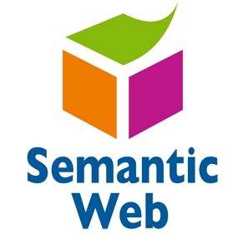

ANGLIA RUSKIN UNIVERSITY

|  |
| --- |
|  |
| **MOD004979**  Semantic web report |
| |  |  |  | | --- | --- | --- | | Joseph Kingsley | 12/12/19 | Anglia Ruskin University | |

Contents

1 Table of figures 3

2 Introduction 5

2.1 Aim & Concept 5

2.2 Literature review 6

3 design 9

3.1 semantic data technology 9

3.2 Ontology for the Nutrifoods website 11

3.2.1 Protege 11

3.2.2 Nutrifoods ontology 12

4 Implementation 20

4.1 Environment set-up 20

4.1.1 Fuseki 20

4.1.2 PHP 20

4.2 SPARQLIB 21

4.3 Web Application 24

5 Evaluation & use 32

5.1 First Query 32

5.2 Second query 34

5.3 Third query 35

5.4 Fourth query 37

5.5 Fifth query 40

6 critical reflection 41

7 conclusion 43

8 References 45

9 Appendices 47

9.1 Appendix A 47

# Table of figures

Figure 1:Foodon ontology 7

Figure 2: (myfooddata, 2019b) 8

Figure 3:Ontology title page 12

Figure 4:Nutrifood Ontology metrics 12

Figure 5:Nutrifood class hierarchy 13

Figure 6:Nutrifood object properties 15

Figure 7:Nutrifoods data property 16

Figure 8: Nutrifoods individuals 17

Figure 9: Nutrifood ontograf 18

Figure 10: showing the individual relation 18

Figure 11: showing the realtion beteeen classes 19

Figure 12 21

Figure 13 22

Figure 14 23

Figure 15 24

Figure 16 26

Figure 17 26

Figure 18 27

Figure 19 27

Figure 20 28

Figure 21 29

Figure 22 29

Figure 23 30

Figure 24 30

Figure 25 31

Figure 26 31

Figure 27 32

Figure 28 32

Figure 29 33

Figure 30 34

Figure 31 34

Figure 32 35

Figure 33 35

Figure 34 36

Figure 35 37

Figure 36 37

Figure 37 38

Figure 38 38

Figure 39 39

Figure 40 39

Figure 41 40

Figure 42 40

Figure 43 41

Figure 44 41

Figure 45 42

Figure 46 42

Figure 47 50

Figure 48 51

Figure 49 52

# Introduction

This report provides analysis of the Food ontology called Nutrifoods by exploring the different parts of the ontology. Semantic data technology was used to build Nutrifoods. This application has similar attributes to other existing websites and mobile application and another food ontology called FoodOn.

This report will be divided into different parts which are the aim and concept, design, implementation, evaluation and use, critical reflection, conclusion and references. The concept and aims which is where the idea of the application will be explained. The design section of the report will look at semantic technology and what it is about, it will also look at the ontology of Nutrifoods in protégé. This will be going into each section of the ontology in depth and explain them. The next part will be the implementation which will look website and the programming code used to display the result on the front -End of the website, how the end user will search for things on the website. The evaluation and use part of the report will explore the SPARQL queries used by the application and the results they bring out when used and what platform was used to test them. The critical reflection section will the whole report and compare it with existing report and how the report was handled. Conclusion part will give a summary of the whole report and finally references will enable readers the option for further research if need.

## Aim & Concept

The aim of this report is to use a semantic data technology with a web application which will be applied to a food nutrition website called Nutrifoods. This application creates a single place from where different kind of food can be searched and their corresponding nutrients can be seen. There are similar mobile application and web application (<https://www.myfooddata.com/>) that has done this concept and similar ontology which has done it called FoodOn which will be explored in the literature review part in the next subsection.

This application gives a place for users from different parts of the world to search for nutrients information about a type of food and what class of nutrients that nutrient belongs to. The main purpose of Nutrifoods is to give information about foods. By applying semantic data technology on food, it enables the information more readable and more user friendly. A good use of this ontology is for researchers who want to do research on a similar field of study.

## Literature review

This section will look at previous website and ontology that are like The Food score mobile application, website (thekitch.com, allrecipies.com, fooddata.com, chowhound.com), FoodOn (foodon.org), etc. For this paper the fooddata website and Foodon ontology will be compared to Nutrifoods. There will be a brief introduction into FoodOn and fooddata.com web application about the features they have and how Nutrifood ontology took many inspirations for building its features from both.

FoodOn ontology is an ontology about food ontology that gives an accurate and consistent description about food that are well known in different cultures all over the world (Service, 2019). It is an easy and comprehensive driven consortium project ontology. It uses the ontology lookup service (OLS) database to get its information (Ebi.ac.uk, 2019). The purpose of this ontology is to monitor outbreak analysis and routine surveillance of possible pathogens that can come from food. Many other research communities joined the consortium like OBOFoundry.org.

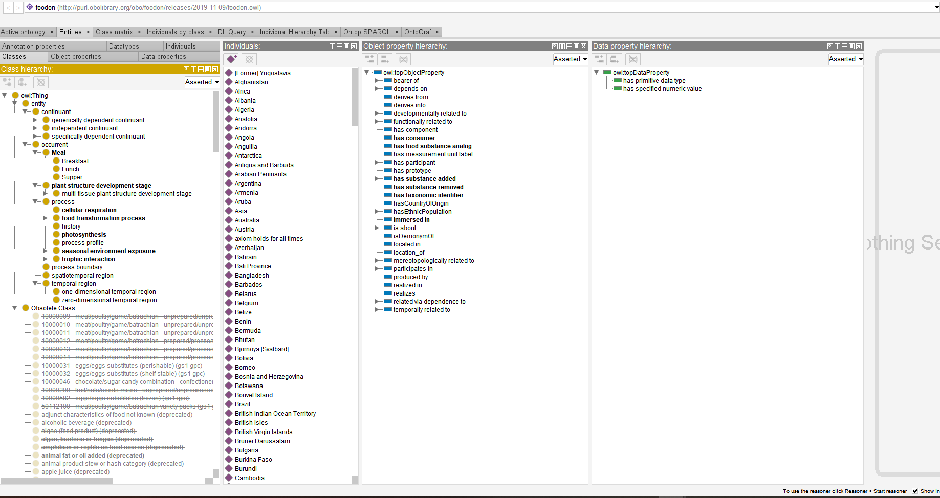

Figure :Foodon ontology

As shown from figure 1 the ontology is different to the Nutrifoods ontology (which will be shown in chapter 3 of this report). The features that was taken form the foodon are mainly how the individuals relate to the main classes and how the object properties connect the domain and ranges, how the object properties connect individual to each other. The major differences are the purpose of the ontologies and the classes. The purpose of Nutrifoods is for providing information about a food with different details like nutrient levels (including minor and major nutrients) and major food group, which is different from foodon. The classes are also different as shown in figure 1.

myFooddata.com website is a website that show the nutrients of food. It gets its data source from U.S agricultural research service food data central (myfooddata, 2019a)

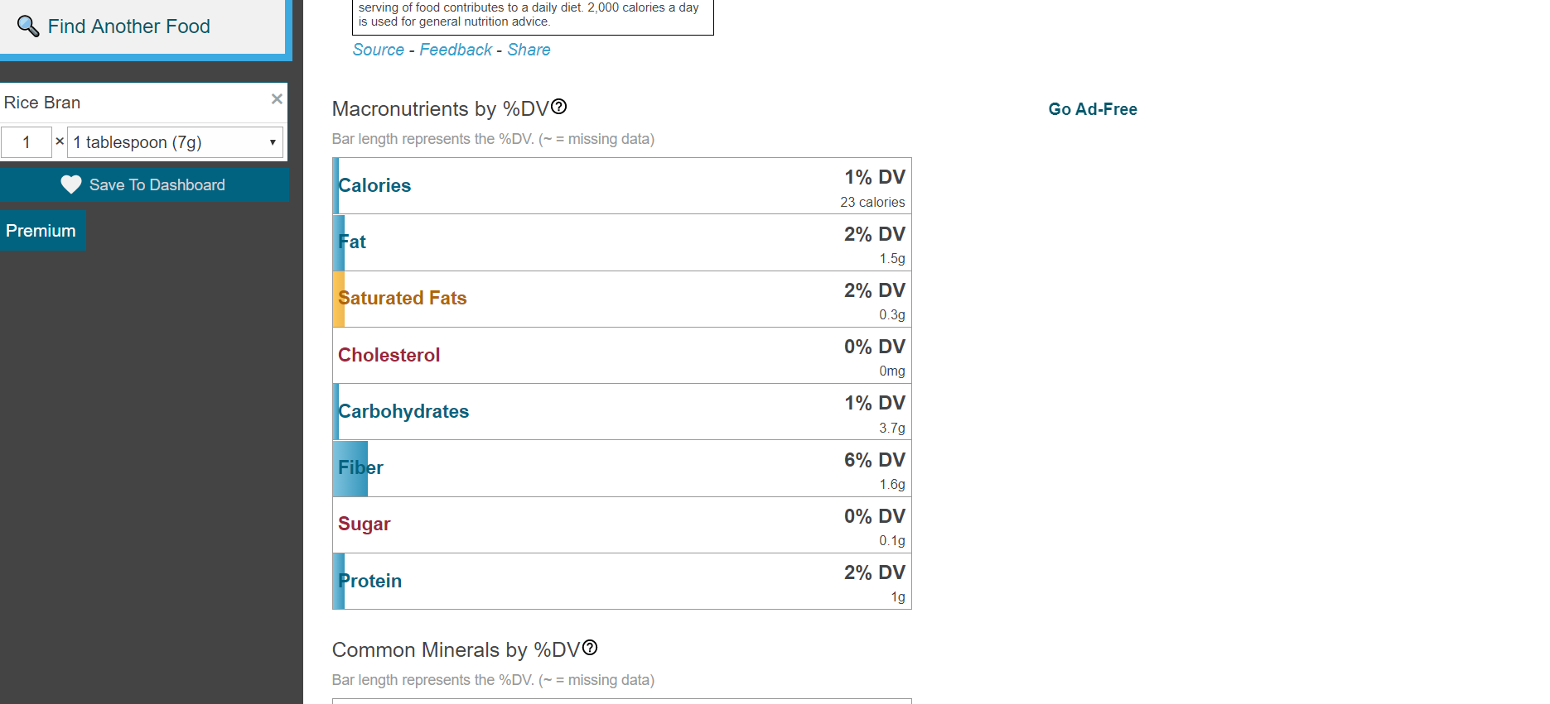

Figure : (myfooddata, 2019b)

Many of Nutrifoods data properties are gotten from myfooddata website like the level of grams of protein, water, some minerals and vitamins. The way the result of the information of the food is displayed is an inspiration for building the website of Nutrifoods ontology. The major difference is that some types of food in Nutrifood are not in the myfooddata website and myfooddata does not always tell the major food group of a food. It does not also mention what classes the nutrients are from.

Both myfooddata and foodon ontology were inspirations for building the Nutrifoods ontology and website

# design

This part of the report will consider the semantic technology used and the ontology of Nutrifoods website.

## semantic data technology

The semantic data technology also commonly referred to as web3.0 is very useful in solving issues that world wide web has. It refers W3C’s version of the web linked data. This technology gives users the ability to create data stores on the web, writes rules for handling data and build vocabularies (W3.org, 2019). It defines and links data on the web or within a company or enterprise by developing self-describing interrelation, languages to express very good relations of data between machines in the way that it can process(W3.org, 2019). Tim Berners-Lee was the inventor of world wide web and was the first to suggest the idea in the late 1980s (Cambridge Semantics, 2019). DBpedia is an example of a linked datasets which presents the content of Wikipedia in RDF (Anon, 2019).

Semantic web technology uses a term called ‘triple’ to represent relation between subject and an object. Connection between a subject and a object is done by a predicate. An example of a triple from Nutrifoods looks like this: **banana has_minerals calcium.** From the example given **banana** is the subject, **has_minerals** is the predicate and **calcium** is the object. Objects and subjects are equivalent to entities, which are called classes. Predicates are the properties of entities. Data property, object property and annotation property are different types of properties.

Triples need to be used to create a dataset, which means some concepts must be understood. The concepts are RDF (Resource Description Framework), SPARQL (Simple Protocol and RDF Query Language), URI (Universal Resource Identifier. URI make it possible to use similar thing as others.

RDF is used in semantic data for data interchange (W3.org, 2019). RDF uses triples for expressing people and machines data (W3.org, 2019).

SPARQL is data-oriented and a query language that is used to query semantic data (Ontotext, 2019a) It is language used to query for RDF graphs. It uses URIs prefixes and filters the result of the query, order and group it by a variable. It has CONSTRUCT, ASK, SELECT, DESCRIBE forms of query. The SELECT query is used to get values from the RDF files. Some query modifiers are LIMIT, ORDER BY, OFFSET, BIND, GROUP BY. The LIMIT restricts the result it can display to a certain number. OFFSET removes the amount of result from the first to what ever number that has been decided to be removed. ORDER BY arranges(sorting) the result displayed in a certain order depending on what is used after it. GROUP BY allows aggregation over one or more properties. BIND permits a value from the RDF files to be assigned to a variable from a property path expression or basic pattern.

The model must be very clear and accurate in order for the queries to work properly.

## Ontology for the Nutrifoods website

### Protege

Protégé was used to create the ontology for this project. Protégé is java-based software and a ontology editor software. protégé was used to design the ontology of the Nutrifoods website. It was developed at Stanford university school of medicine by the Stanford biomedical informatics research. It is a knowledge-base and open source ontology editor framework that is free to use. There are two main ways of modelling ontologies that the protégé platform supports which are protégé OWL and protégé-Frames. There different formats which protégé ontologies can be exported, these include: RDF(S), XML schema, OWL (Dcc.ac.uk, 2019 It has two major functionality which are: enabling users to populate and build ontologies that are frame-based which in line with OKBC (open knowledge base Connectivity protocol); it also enables the building of ontologies for the semantic web, particularly OWL (W3c’s web Ontology Language) by users (Dcc.ac.uk, 2019).

### Nutrifoods ontology

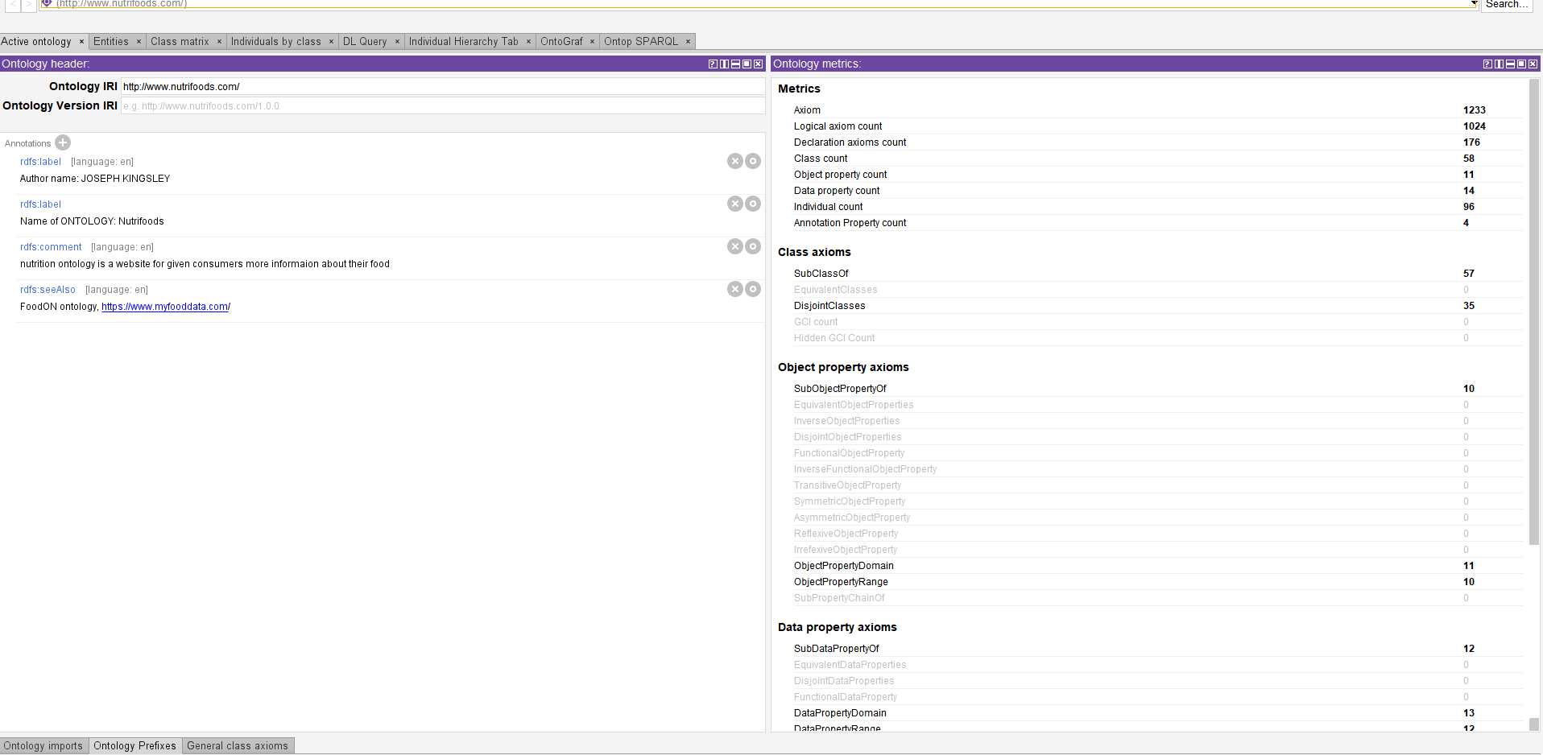

Figure :Ontology title page

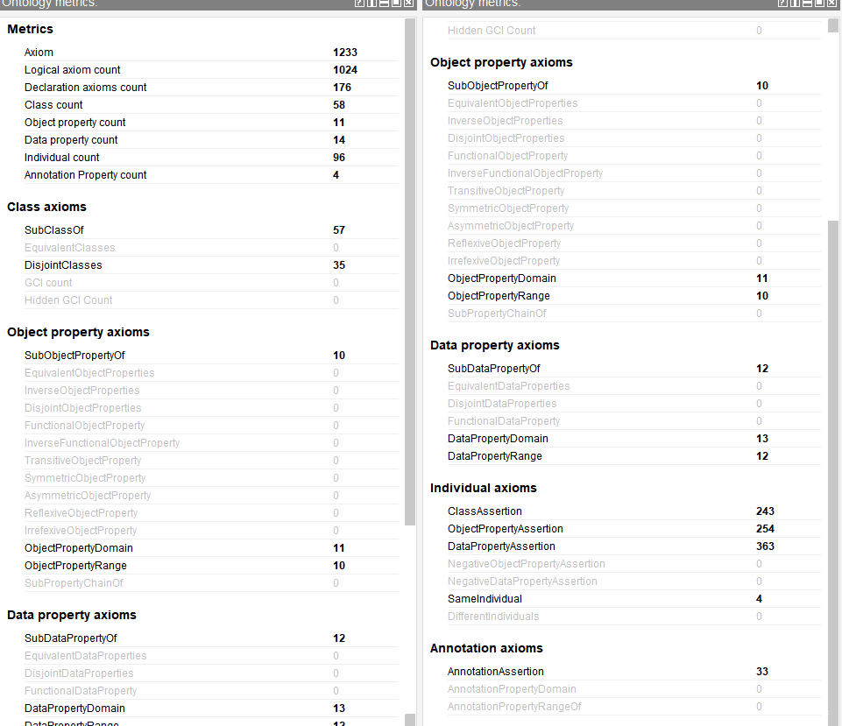

Figure :Nutrifood Ontology metrics

As shown in figure 4 from protégé the ontology has 1233 axioms, 58 classes, 11 object properties, 14 data properties, 96 individuals. Every individuals were collected from different food websites including myfooddata.com.

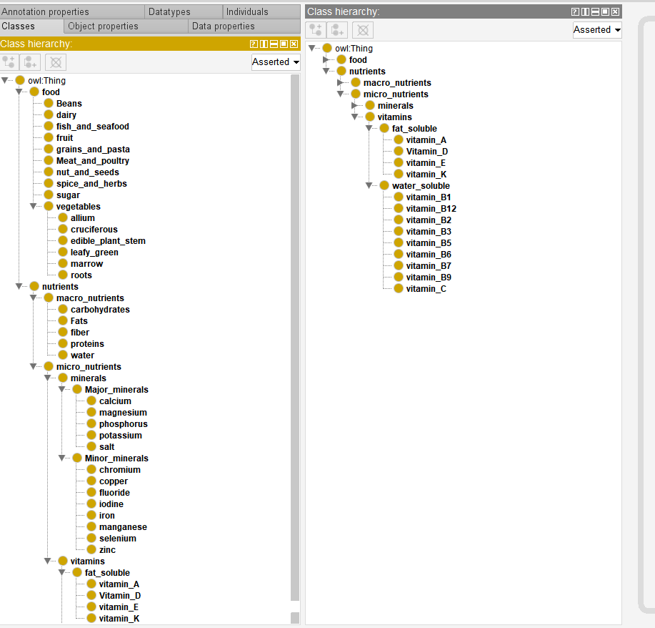

Figure :Nutrifood class hierarchy

Figure 5 shows the class hierarchy which has super classes and some subclasses. The main classes are: **food** and **nutrients**. There are subclasses for **food** and **nutrients**. The subclasses of the **food** category are: **Beans, dairy, fruit, grains_and_pasta, Meats_and_poultry, nut_and_seeds, spice_and_herbs, sugar, vegetables.** There are subclasses that also have subclasses. The subclass of **vegetables: allium, cruciferous, edible_plant_stem, leafy_green, marrow, roots.**

The **food** represents every type of food in the ontology. **Beans, dairy, fruit, grains_and_pasta, Meats_and_poultry, nut_and_seeds, spice_and_herbs, sugar, vegetables** which are all subclasses of **food** representing the different types of **food** that can be found in the ontology like oranges, cucumber white rice etc.

The subclasses of **nutrients** category are: **macronutrients** and **micronutrients.** These two subclasses also have subclasses. The subclasses of **macronutrients** are: **carbohydrates, Fats, fiber, proteins, water**. The subclasses of **micronutrients** are: **minerals** and **vitamins**. The subclasses **minerals** and **vitamins** also have subclasses. The subclass of **minerals** are: **major_minerals** and **minor_minerals**. The subclasses of **vitamins** are: **fat_soluble** and **water_soluble**. The subclasses of **major_minerals** and **minor_minerals** have subclasses. The subclasses of **major_minerals** are: **calcium**, **magnesium**, **phosphorus**, **potassium**, **salt**. The subclass of **minor_minerals** are: **chromium**, **copper**, **iodine**, **iron**, **manganese**, **selenium**, **zinc** and **fluoride**. There are also subclasses of **fat_soluble** and **water_soluble.** The subclass of **fat_soluble** are: **vitamin_A**, **Vitamin_D**, **vitamin_E** and **vitamin_K**. The subclasses of **water_soluble** are: **vitamin_B1**, **vitamin_B12**, **vitamin_B2**, **vitamin_B3**, **vitamin_B5**, **vitamin_B6**, **vitamin_B7**, **vitamin_B9** and **vitamin_C.**

**nutrients** category is a large class with different subclasses, which those subclasses also have subclasses. The different types of **nutrients** and its subclasses of those subclasses are all **nutrients** but divided into specific categories to provide the user with accurate information of each **nutrients.**

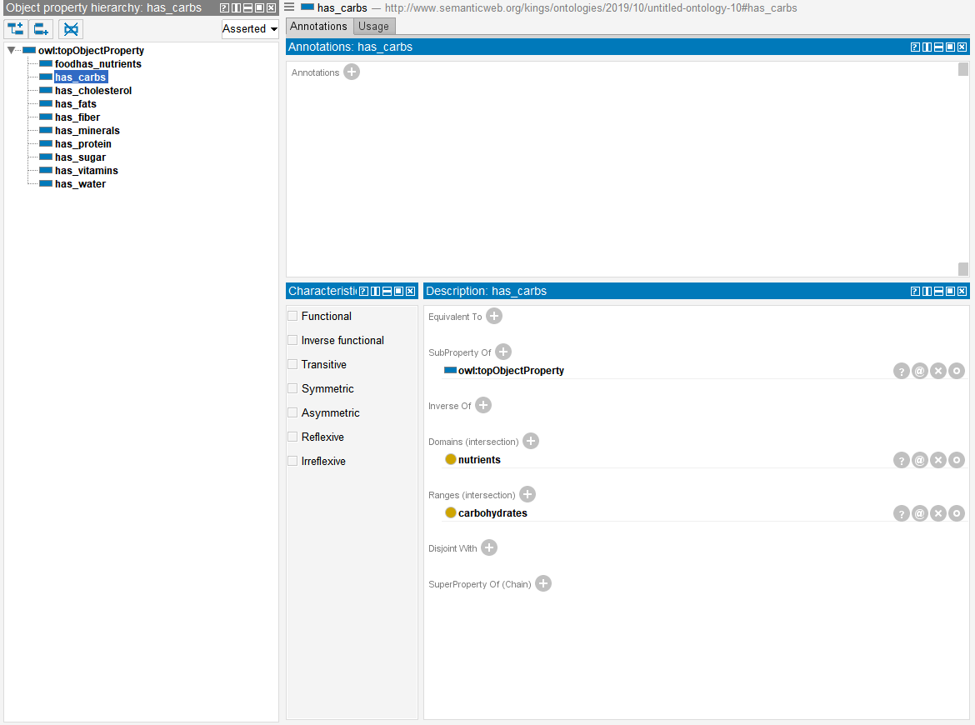

Figure :Nutrifood object properties

The next thing that this report will look at will be the data property as shown in figure. This relationships forms triples in the ontology.

Nutrifoods currently has different object properties like **has_carbs**, **has_cholesterol**, **has_fiber**, **has_vitamins**, **has_water**, **has_minerals** etc as shown in figure. The selected object property is **has_carbs** has **nutrients** as its domain and **carbohydrates** as its range of the triple. **has_protein, has_minerals, has_fats, has_fiber, has_vitamins, has_water** has **nutrients** as its domain. **has_sugar** has its domain as **food** and range as **sugar.**

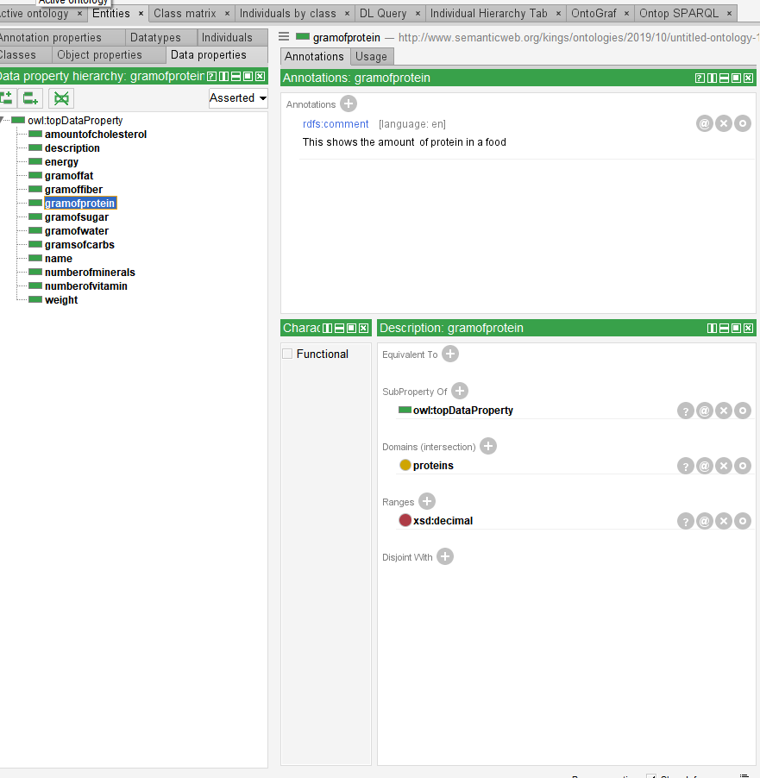

Figure :Nutrifoods data property

Individuals have data properties in an ontology. Figure shows the data property in the ontology for Nutrifoods. As shown in figure **gramsofprotein** has its domains as proteins and the range as **xsd:decimal. gramoffiber**, **gramofsugar**, **gramofwater**, **gramoffat, gramsofcarbs** all have **xsd:decimal** as the range

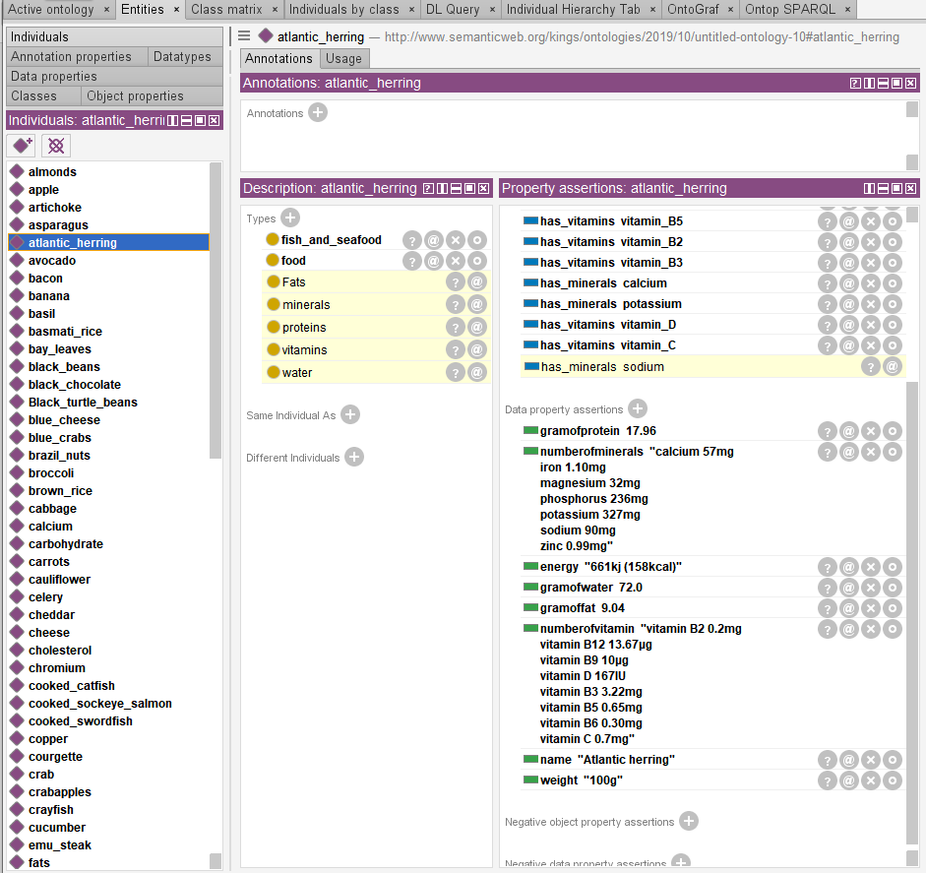

Figure : Nutrifoods individuals

Figure shows some of the individuals listed in the ontology which belong to both the **food** and **nutrient** class. The selected item is a instance of the **food** class and it has object properties such as **has_vitamins, has_minerals, has_fats, has_water, has_protein. has_vitamins** data property connects it to the subclass **vitamins. has_vitamins** is used more than once because of the different **vitamins** found in it. **has_minerals** also has more than one because the different categories of minerals found in it. it connects the individuals to the subclass **minerals.**

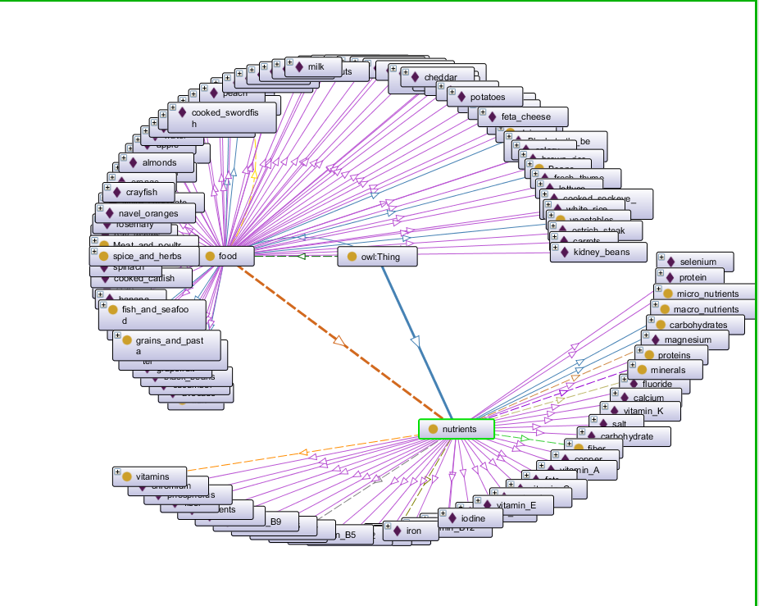

Figure : Nutrifood ontograf

Figure 9 shows all the relations and individuals for the **food** and **nutrient** class and the relation between the two classes.

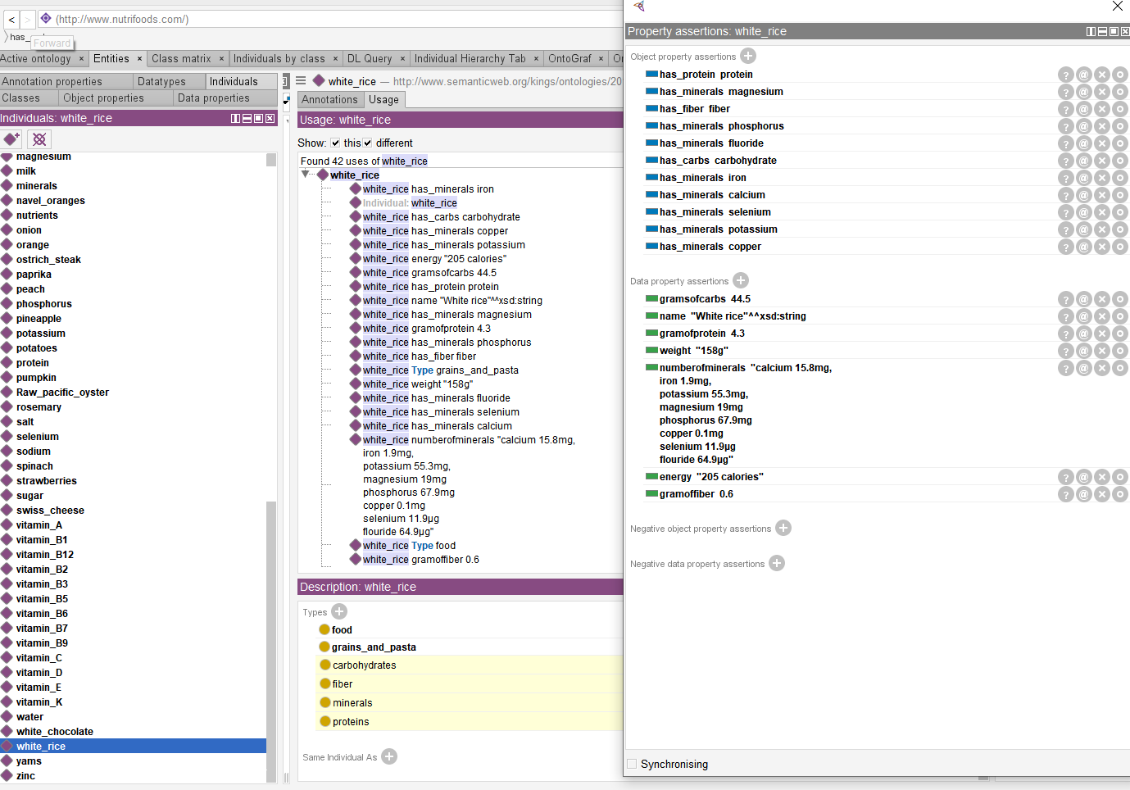

Figure : showing the individual relation

Figure shows how an individual from the **food** class is used in the ontology. It shows all the data properties and data properties for the selected **food.** The object property **has_minerals** refers to the fact that is has a particular **mineral** that is found in the **mineral** subclass. It also shows that the individual has a **nutrient** class and that **nutrient** class is under the **mineral** subclass. The data property **gramsofprotein** signifies the individual has a quantity of **protein** class in it.

Figure also shows the value of the data properties for the individual selected. The data property helps to give individual specific data.

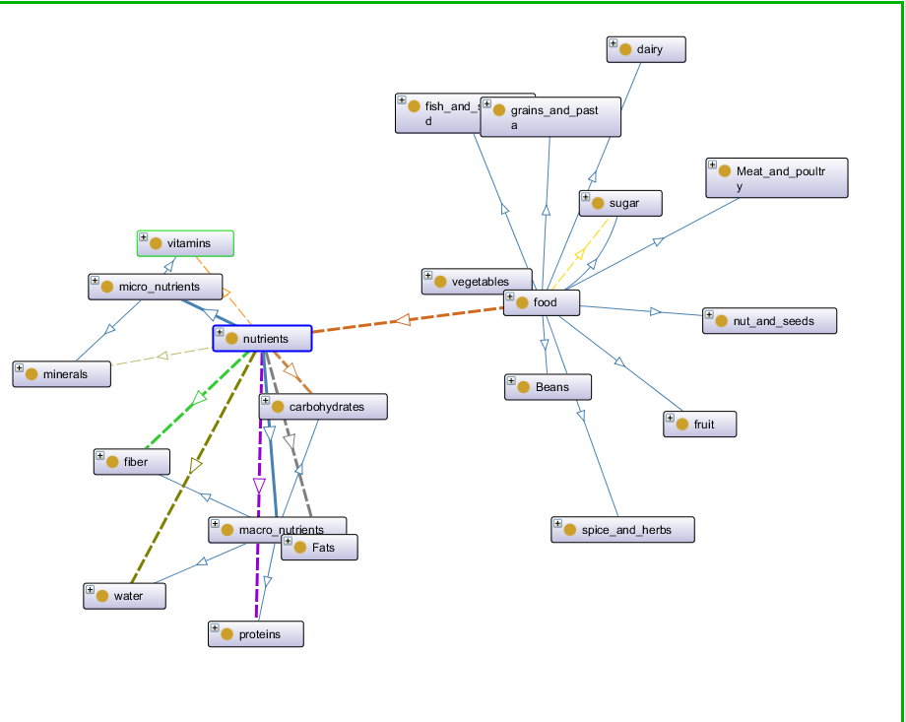

Figure : showing the realtion beteeen classes

Figure 11 shows the main classes of the ontology

# Implementation

This part of the report will look at the website. It will consider the tools used for making the website, the lines of code used in making the website and connecting it to the back-end. How it interacts with Fuseki server and giving a brief explanation on how fuseki server works.

## Environment set-up

For the use of semantic data, the application will need to request and retrieve data. The request is done by using SPARQL server, which is named Fuseki. SPARQL queries do the request and this is done through a SPARQL endpoint. Fuseki is written in java language. PHP programming language was used on the application, but it connected to SPARQLIB which connected it to fuseki.

### Fuseki

Also called Apache fuseki is a free open source java framework, which is used for building linked data and semantic web application. (Jena.apache.org, 2016). It can run as a standalone server, java web application or as an operating system service. Its security is provided by Apache Shiro (Jena.apache.org, 2016). Sparqlib connected the index.php file to the fuseki server. The queries were run on the fuseki server and in the evaluation and use section of the report the queries that were used will be explained in detail.

### PHP

This is server scripting programming language and a very good tool for cresting interactive and dynamic websites. It is free and widely used for web development and can be embedded into HTML. It is an acronym Hypertext pre-processor. It can contain text, CSS, JavaScript and PHP code. The files format look like “.php”. (W3schools.com, 2019).

## SPARQLIB

This is the SPARQ library for PHP that was used to connect the front-end to fuseki.

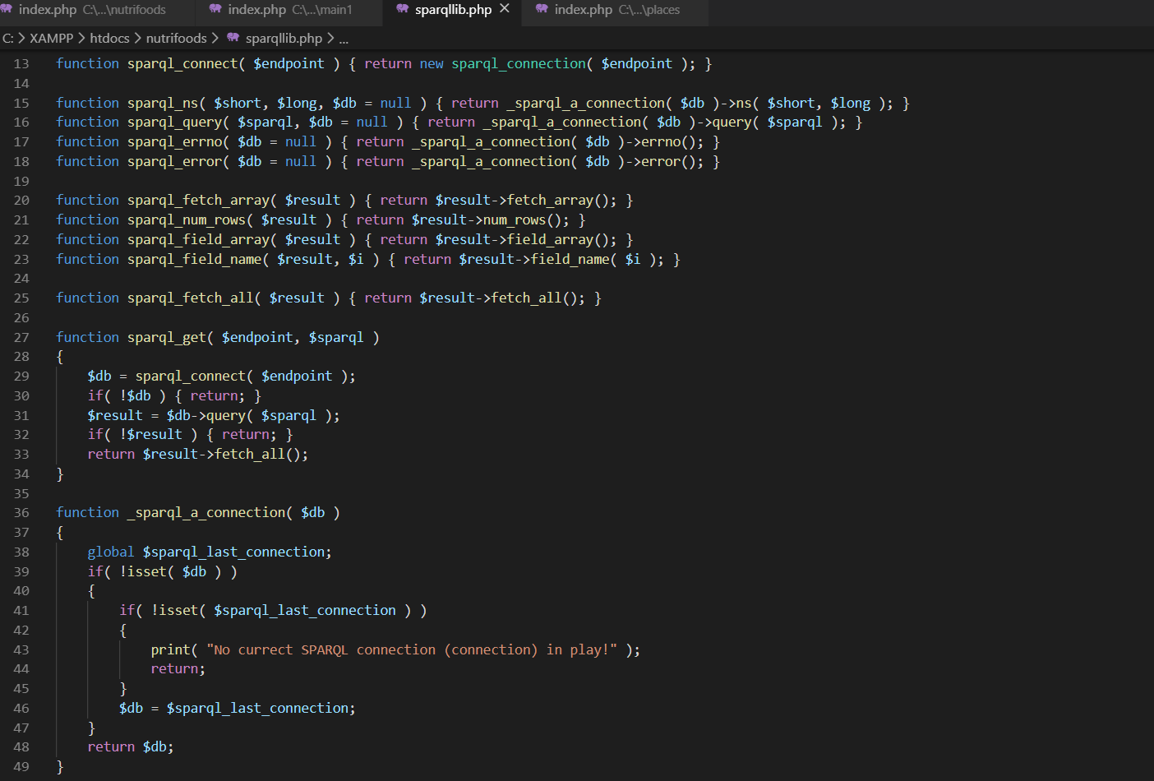

Figure

Figure 12 shows the functions of the sparqlib for connecting to server. It also shows what happens if there is no connection found.

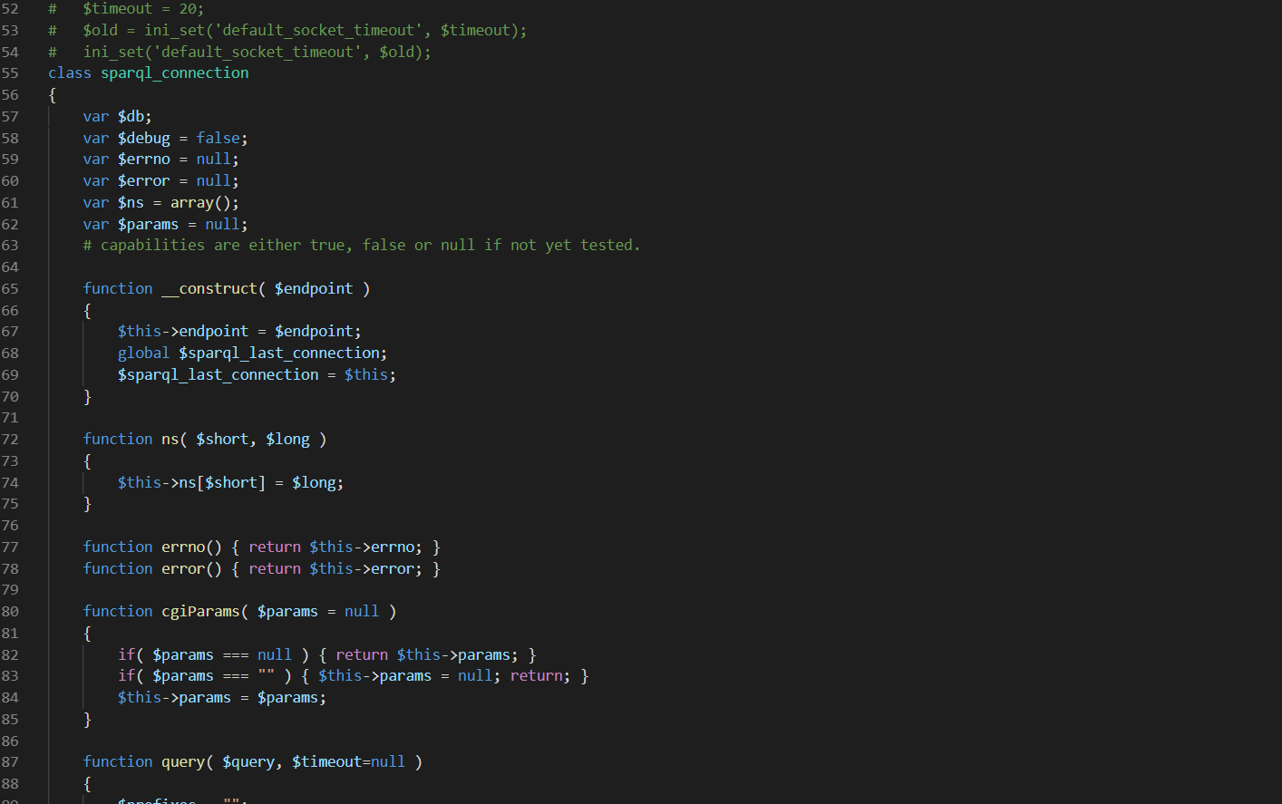

Figure

Figure 13 shows the variables of sparql and what it means..

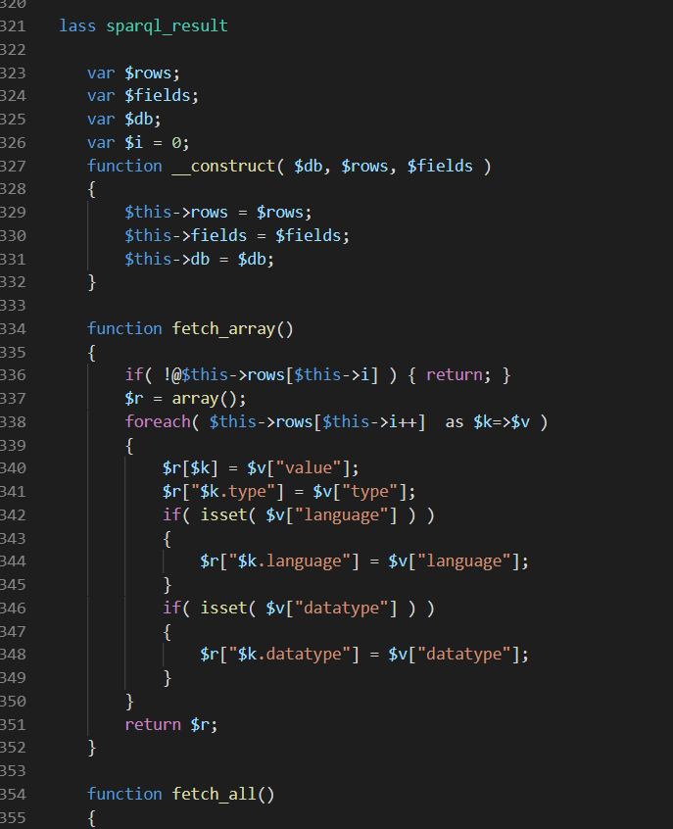

Figure

## Web Application

This section will look at the application and the coding used to show information on the front-end. How the webpage changes according to the information put into it will also be shown.

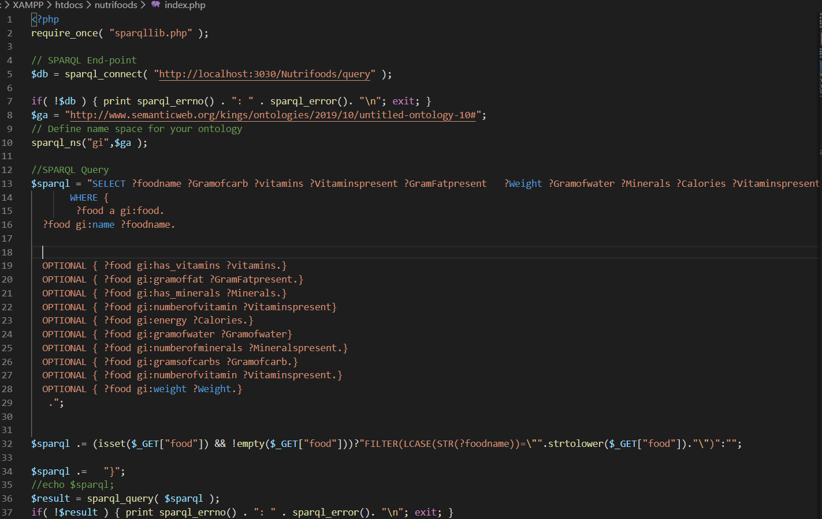

Figure

The figure 15 shows how the application is getting the result on the application and how it connects the fuseki server through sparkql endpoint. require_once( "sparqllib.php" ); connects the index.php to sparqllib.php which has codes embedded in it to connect it to fuseki server amongst other codes.

$db = sparql_connect( "http://localhost:3030/Nutrifoods/query" ); connects it to the database of fuseki where the OWL file has been uploaded which is called Nutrifoods.

The lines of code within the //SPARQL Query up until .”; is the what is displaying the result on the web application. It also setting up the information it wants to retrieve from the database and how it wants to display the information. Without this section of the code there will be not way to get any information form the database because the application will not know what information to get. This displays all the foods in the database with attributes.

sparql_ns("gi","http://www.semanticweb.org/kings/ontologies/2019/10/untitled-ontology-10#"); this line of code puts the URI of the ontology into a name space which is named gi. By doing this the ability to call it whenever ever needed is vital for the programming of the application.

$sparql .= (isset($_GET["food"]) && !empty($_GET["food"]))?"FILTER(LCASE(STR(?foodname))=\"".strtolower($_GET["food"])."\")":""; This line of code is responsible for filtering and getting the correct information which the above lines of code have requested form the database. Without this line of code every information in the data base will displayed when you click the search button. Also, this line of code is telling the application to search for names of food in the database and bring back no result if the name of the food is not in the database. This filter condition can be altered to say anything depending on the condition that needs to be met.

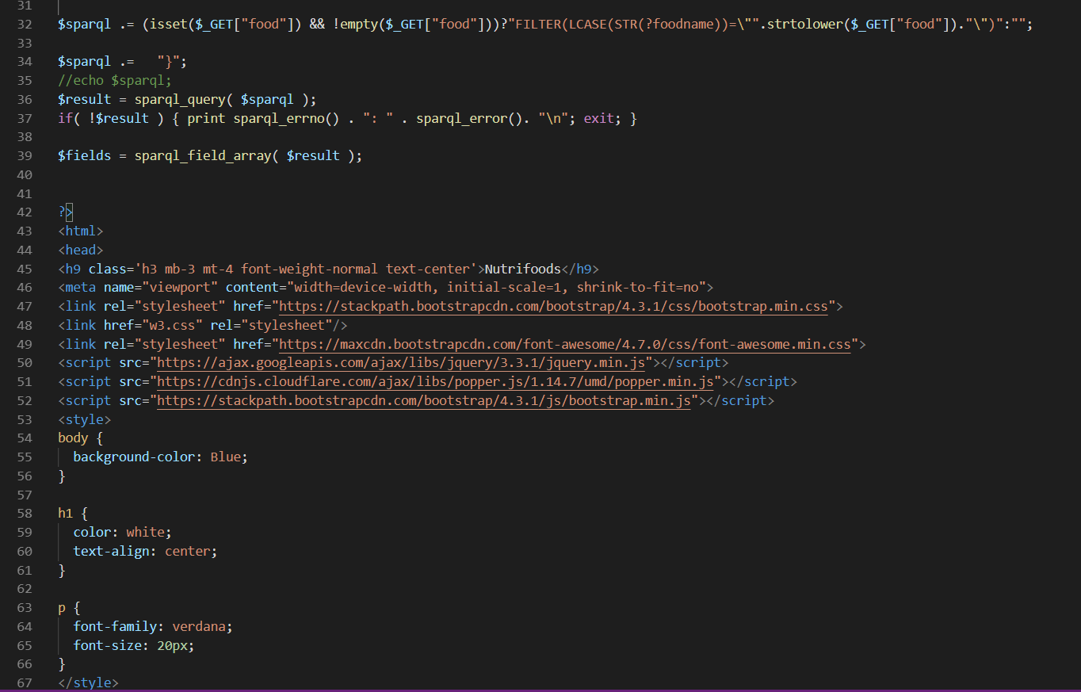

Figure

|  |
| --- |
| $result = sparql_query( $sparql );  if( !$result ) { print sparql_errno() . ": " . sparql_error(). "\n"; exit; }   $fields = sparql_field_array( $result ); |

Figure

Figure 17 shows the line of code that responsible getting the result in arrays and if there is an error display error from the field given in the above code.

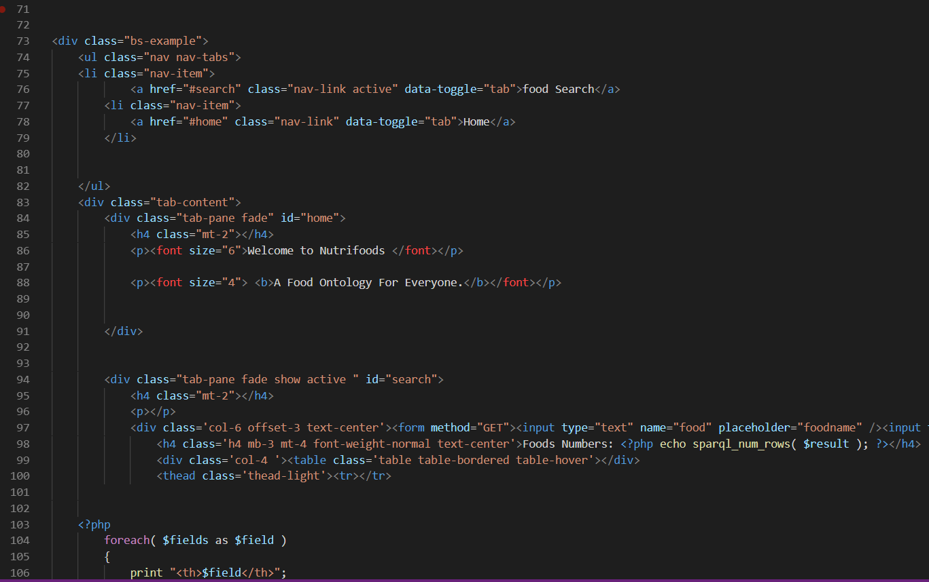

Figure

Figure 18 shows the HTML coding of the website page. This shows how the home page to show “Welcome Nutrifoods” and “A Food Ontology for Everyone”, which includes the size and the placement of the words. It also creates the search tab and button and connects the button to the database by using the GET method. The figure also shows the how the result should be arranged.

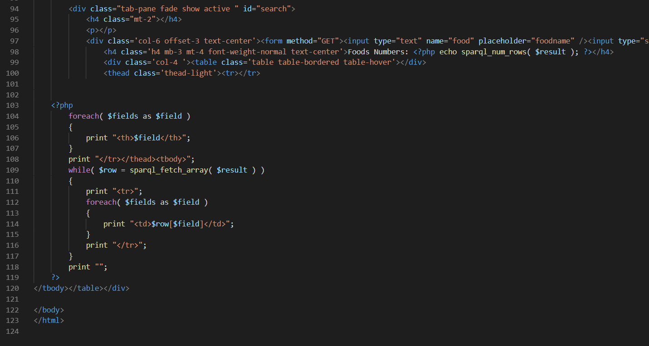

Figure

Figure 19 shows the php telling the application to retrieve information from the database with the fetch array and arrange it according to what the previous codes wanted the information to be arranged in.

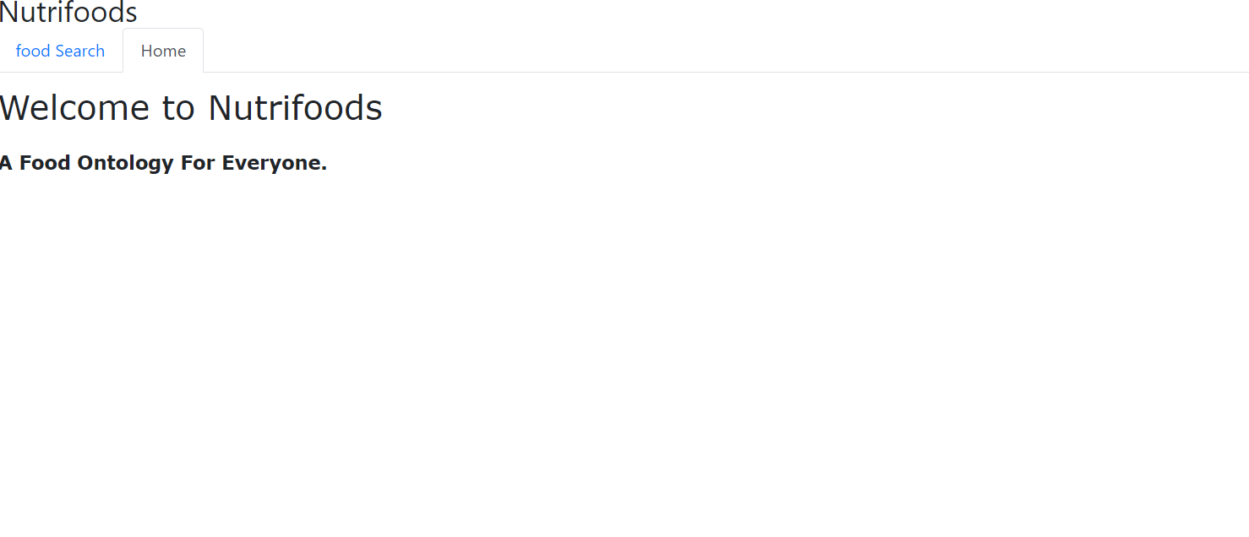

Figure

Figure 20 shows the Home page interface of the website Nutrifoods.

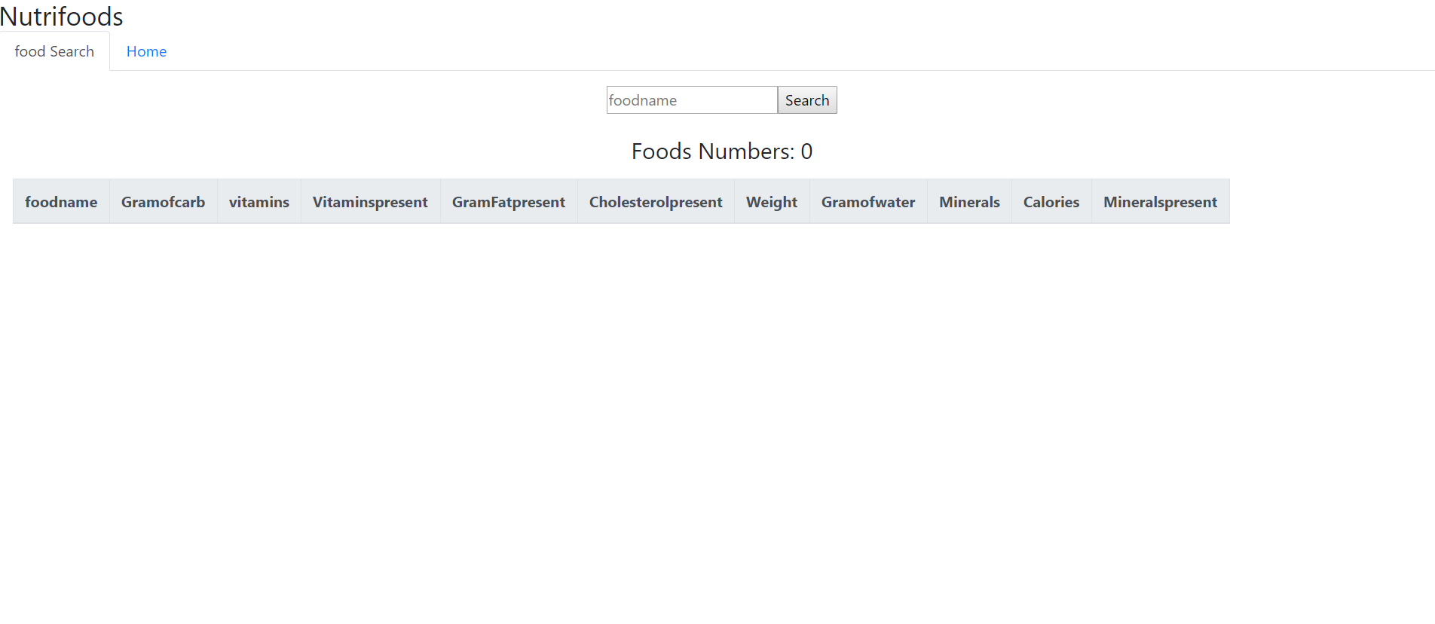

Figure

Figure 21 shows the food search interface, this were users can search for different food and their nutrients found in them. The information is arranged tables for easy understanding.

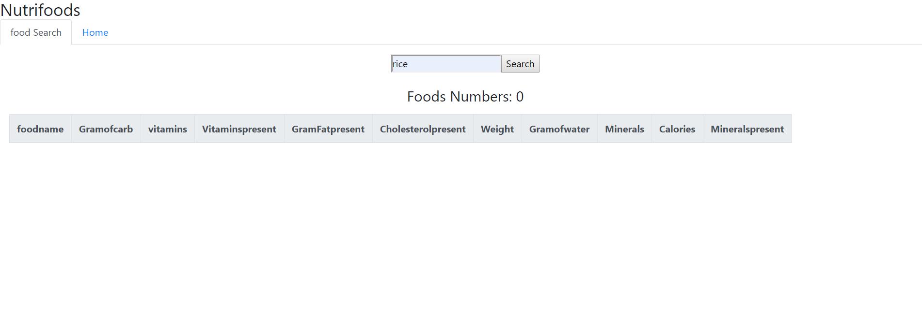

Figure

Figure 22 shows the result for searching for food that is not present in the database. The webpages show no information when the word inserted in the search bar is not found in the database.

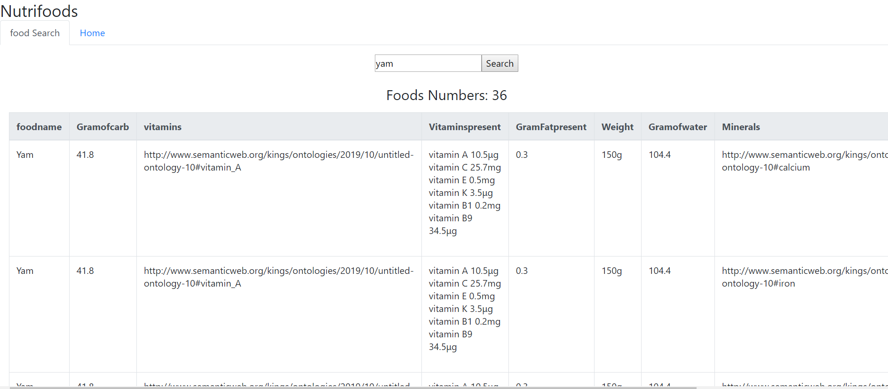

Figure

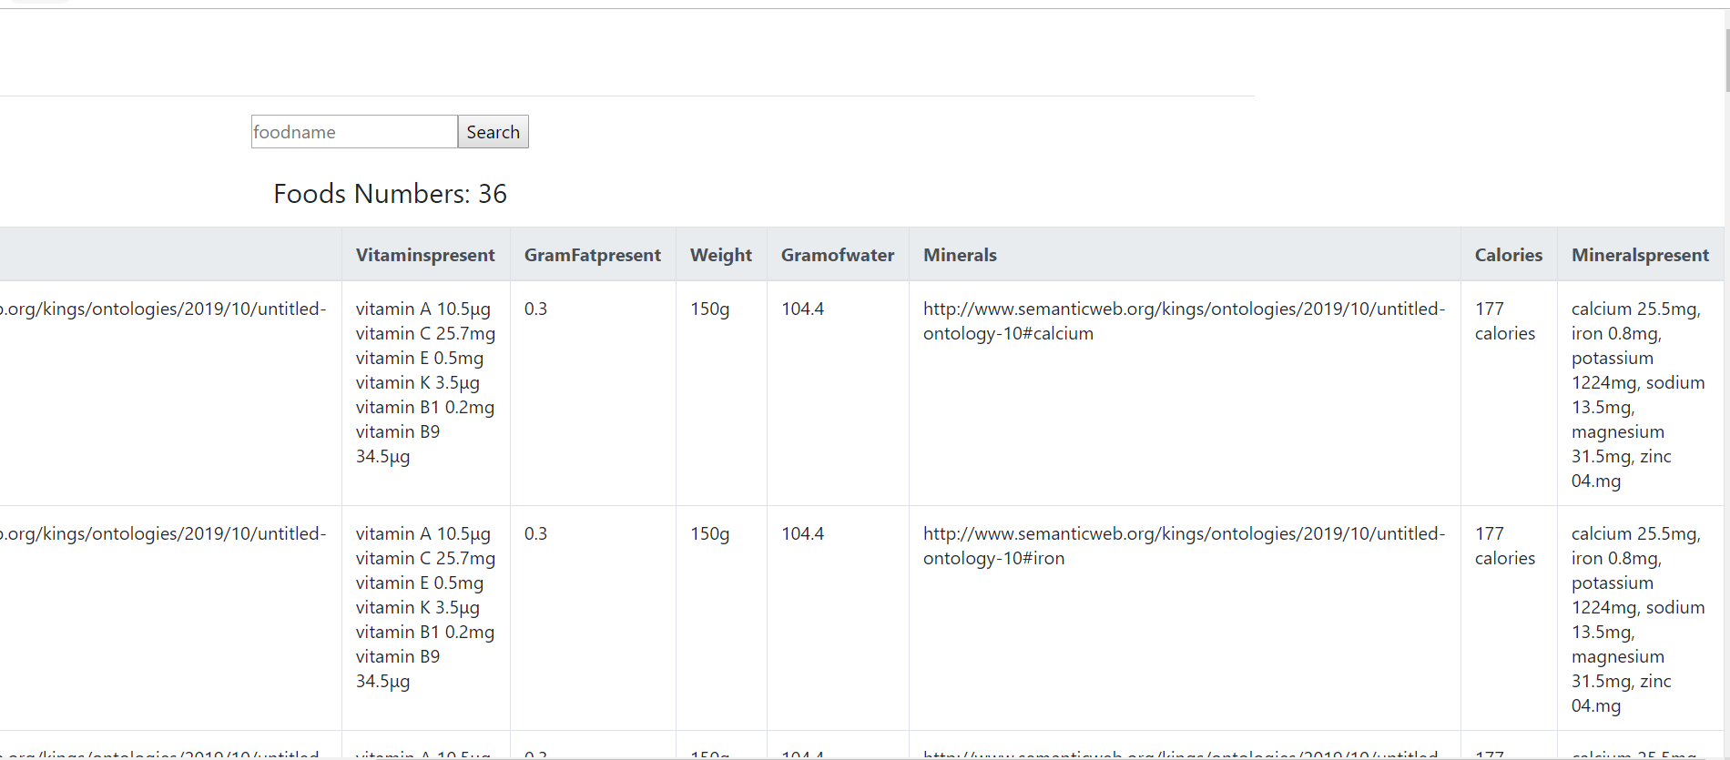

Figure

Figure 23 and 24 shows the result when a word that is found in the database is typed in the search bar. The information for the item which is yam, has different information which is put into the tabs. And the number on the top has changed from 0 to 36 meaning that the number of items counted in the table.

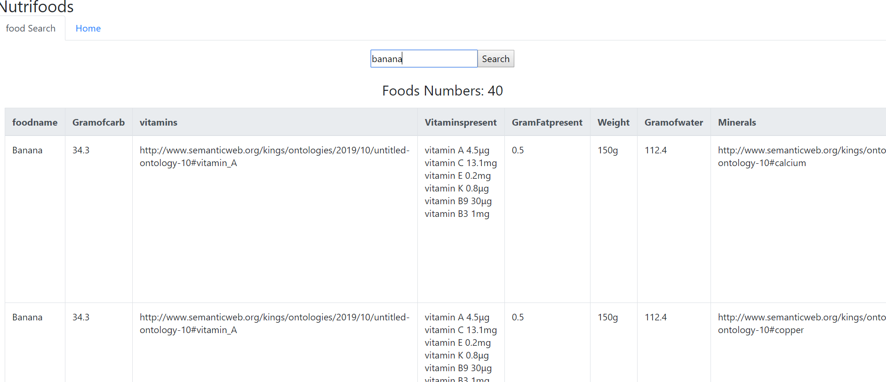

Figure

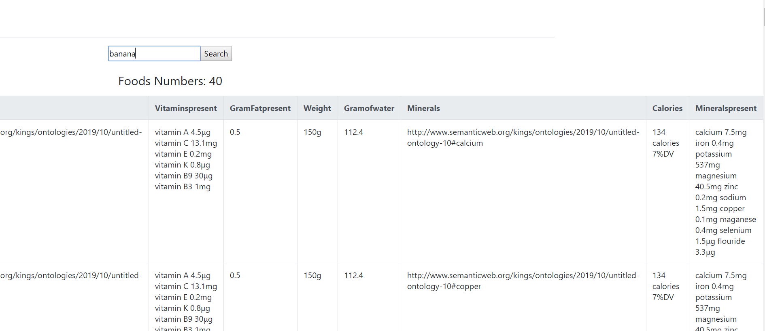

Figure

Figure 25 and 26 shows when a user searches for banana. Other pictures of how other food searches is in the appendix A of this report.

# Evaluation & use

This part of the report shows the SPARQL queries that were used in the application. All the queries were done on the fuseki server.

## First Query

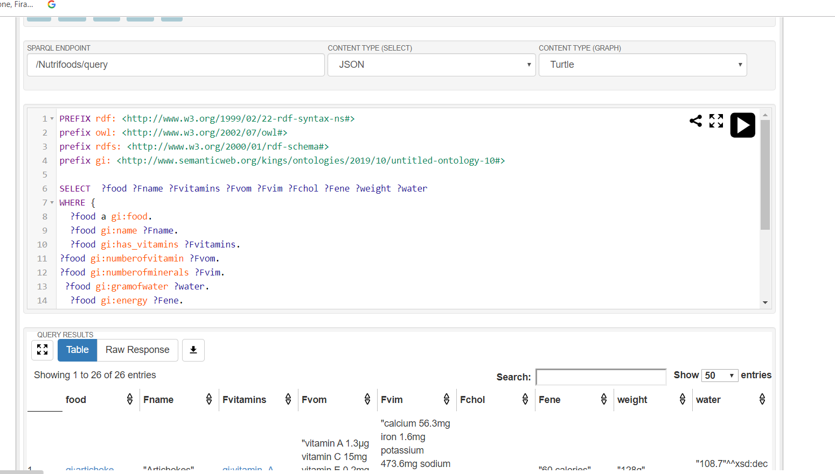

Figure

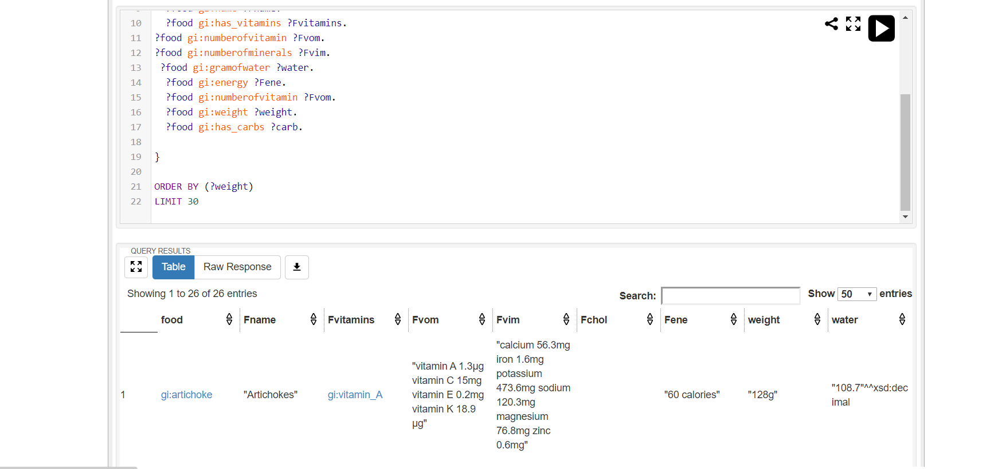

Figure

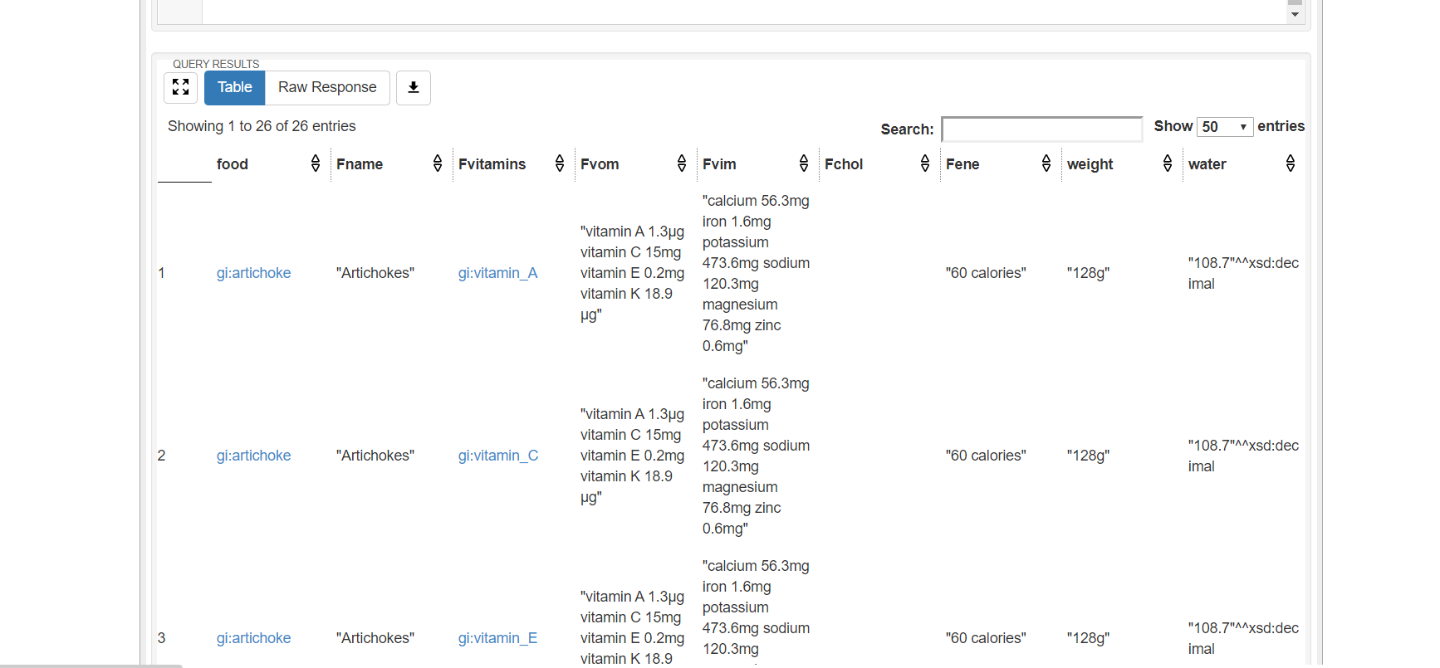

Figure

The function of the query in figure 27, 28 and 29 is to display every food in the ontology that has a vitamin (**has_vitamins**), a carb (**has_carbs**) which are object properties, with the amount of vitamin recorded (**numberofvitamin)**, amount of minerals recorded (**numberofminerals)**, amount of calories recorded (**energy)**, the weight of the food **(weight)**, quantity of water recorded in the food (**gramofwater).** The ORDER BY (?weight) function is used to arrange the result according to weight of each food recorded. The LIMIT 30 function is to limit the result produced to maximum 30.

## Second query

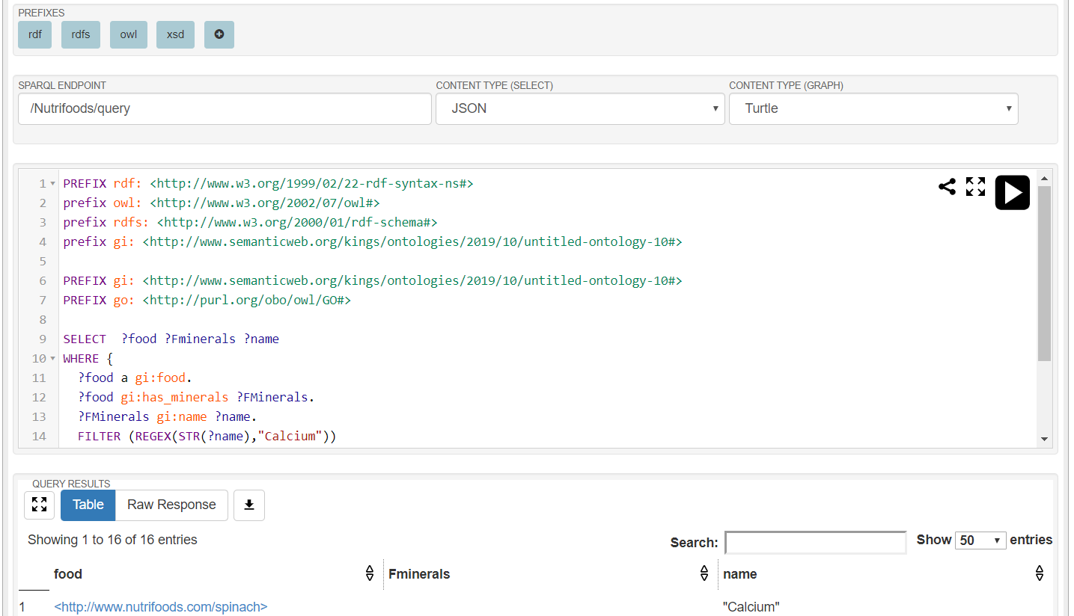

Figure

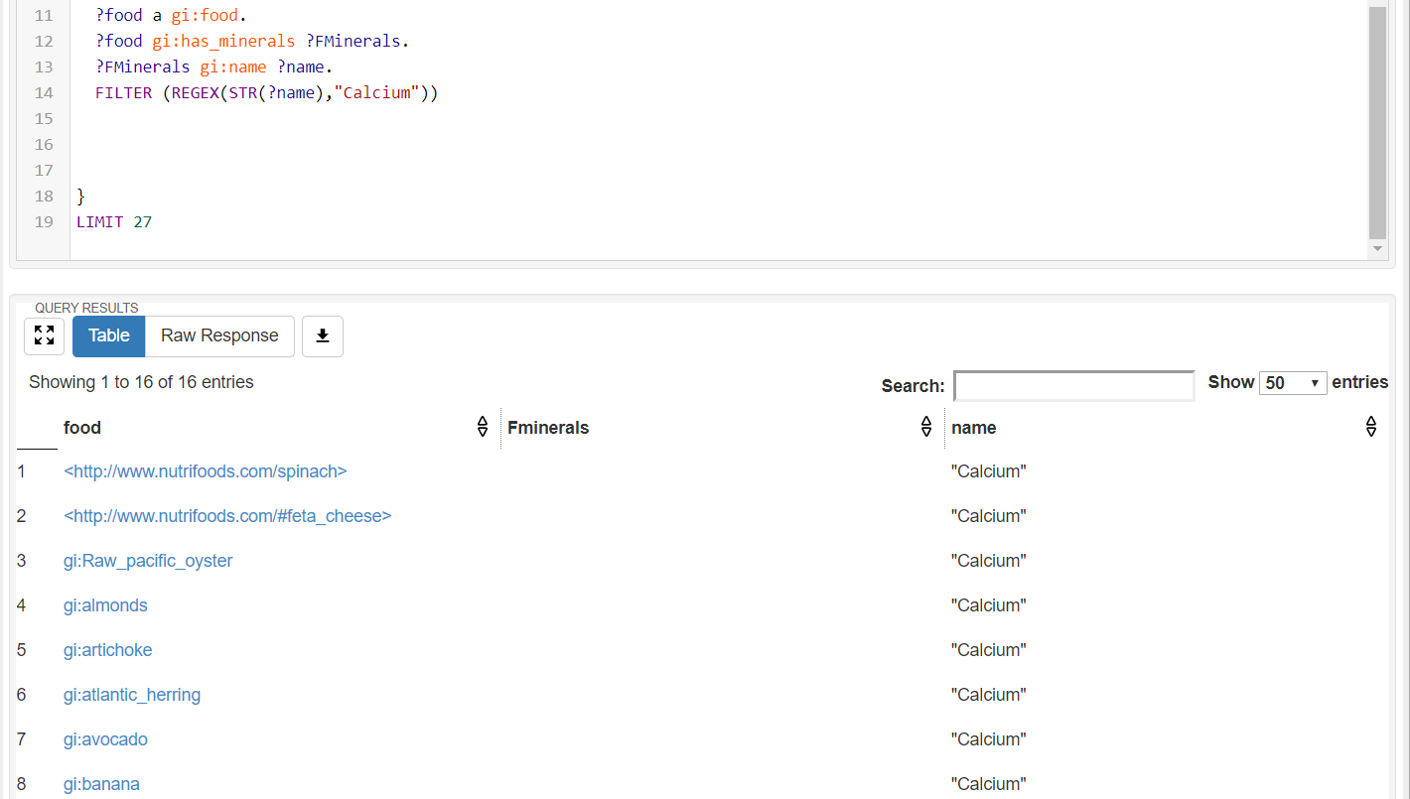

Figure

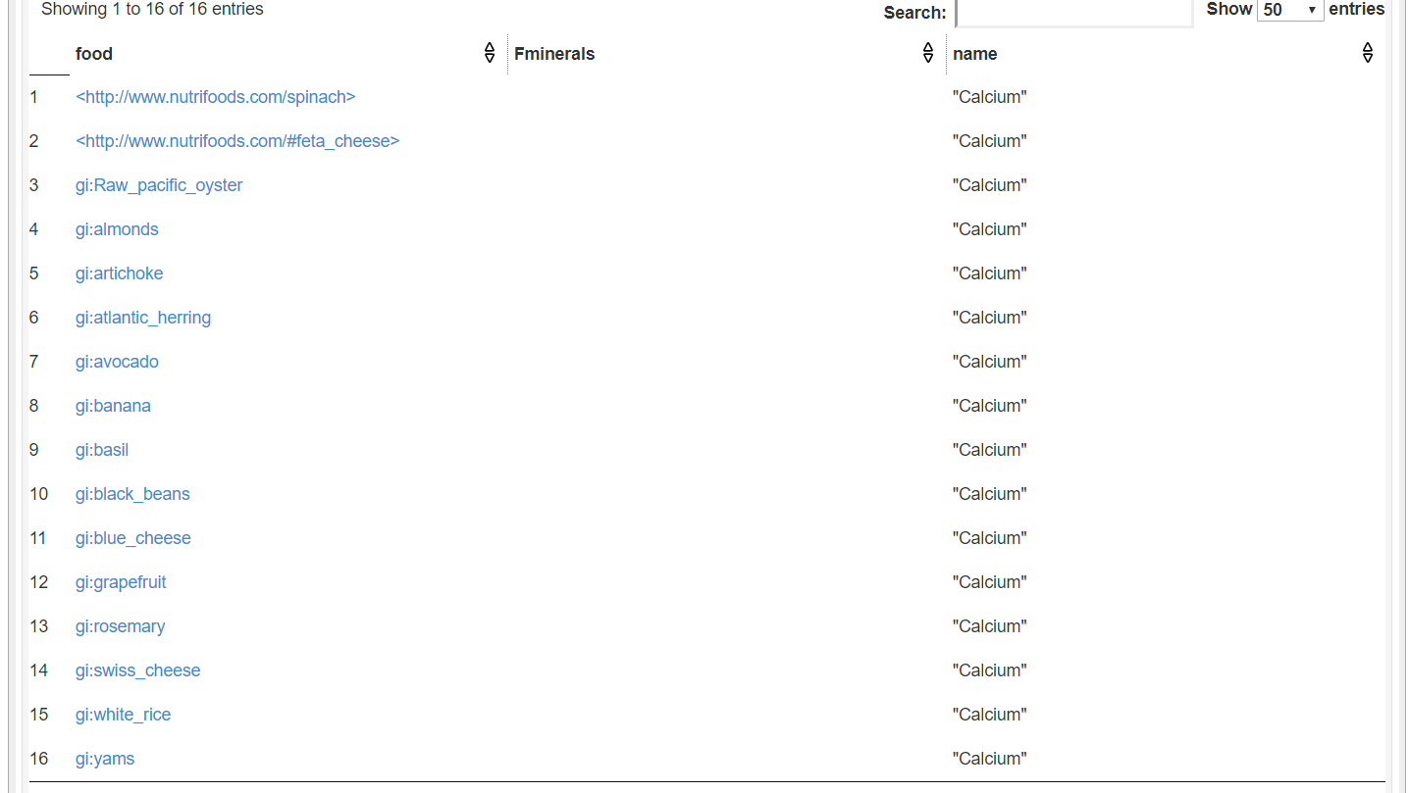

Figure

The function of the query shown in figure 30, 31 and 32 is to display every food in the ontology that has the mineral calcium recorded in them. As the result shows only, a few foods are recorded to have the mineral calcium. The FILTER function is responsible for achieving this result.

## Third query

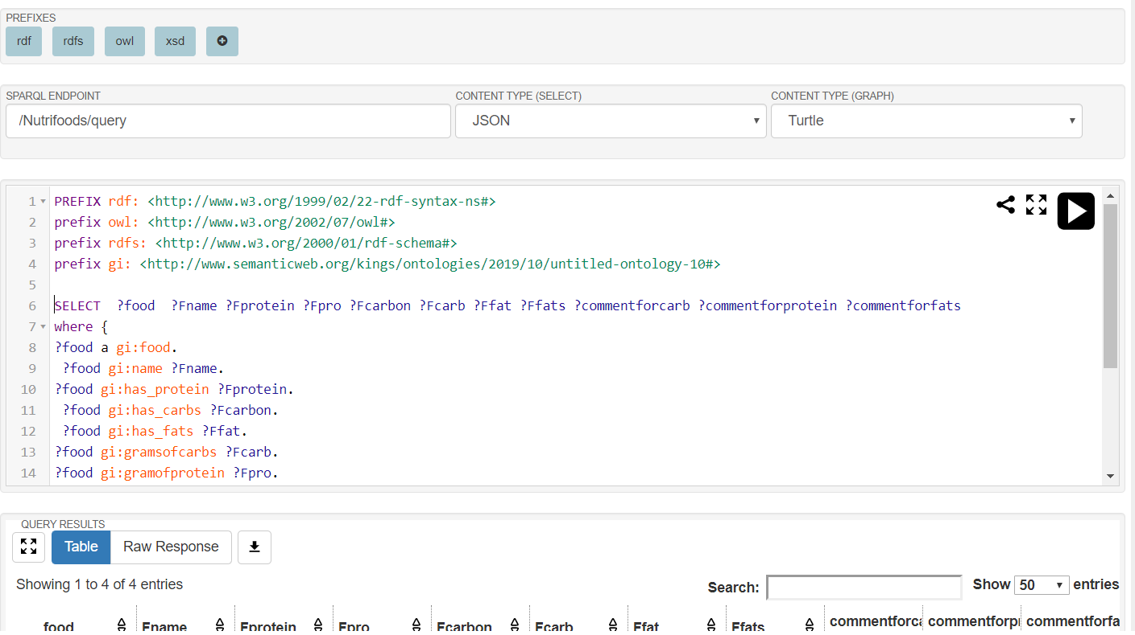

Figure

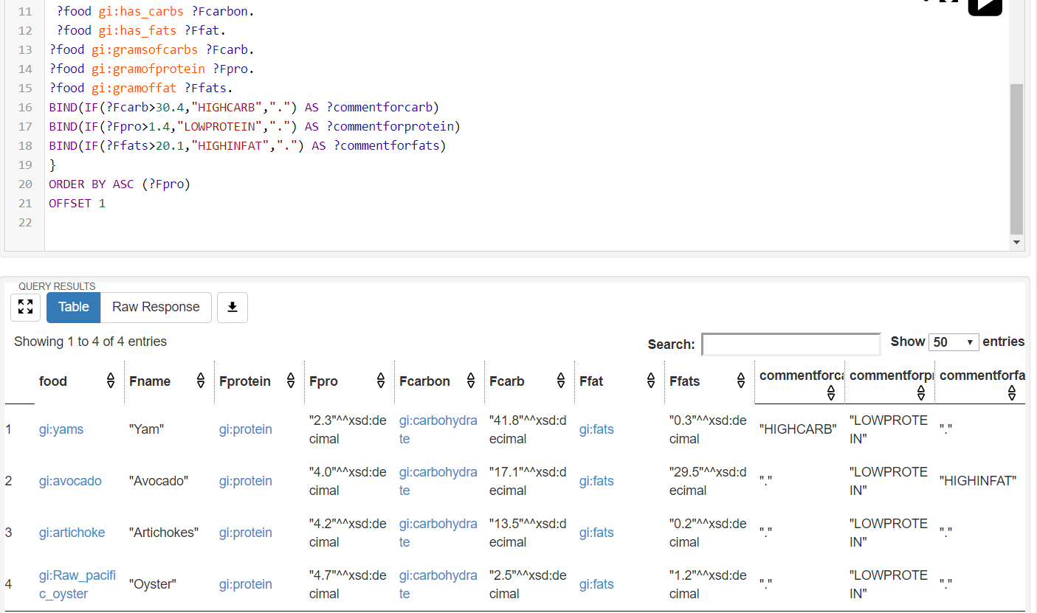

Figure

This function of the query show in figure 33 and 34 was to get every food recorded in the ontology that have protein(**has_protein**), carbohydrate (**has_carbs**). Then display how much carbohydrate they have in grams (**gramsofcarbs**), how much protein they have in grams which was recorded (**gramofprotein**) and how fat in grams was recorded they have (**gramoffat**). The BIND function shown in figure 19 was to use an attribute a comment with a IF statement if certain conditons were met. The conditions that were used are: if the values of carbohydrate is over 30.4 display the comment HIGHCARB and if the value is less than 30.4 display “,”(BIND(IF(?Fcarb>30.4,"HIGHCARB",".") AS ?commentforcarb)); if the value of protein is lower than 1.4 display LOWPROTEIN and if the value is higher than 1.4 display “,” ( BIND(IF(?Fpro>1.4,"LOWPROTEIN",".") AS ?commentforprotein)), and if the value of fat is lower than 20.1 display HIGHFAT and if the value is less than 20.1 display “,” (BIND(IF(?Ffats>20.1,"HIGHINFAT",".") AS ?commentforfats)).

## Fourth query

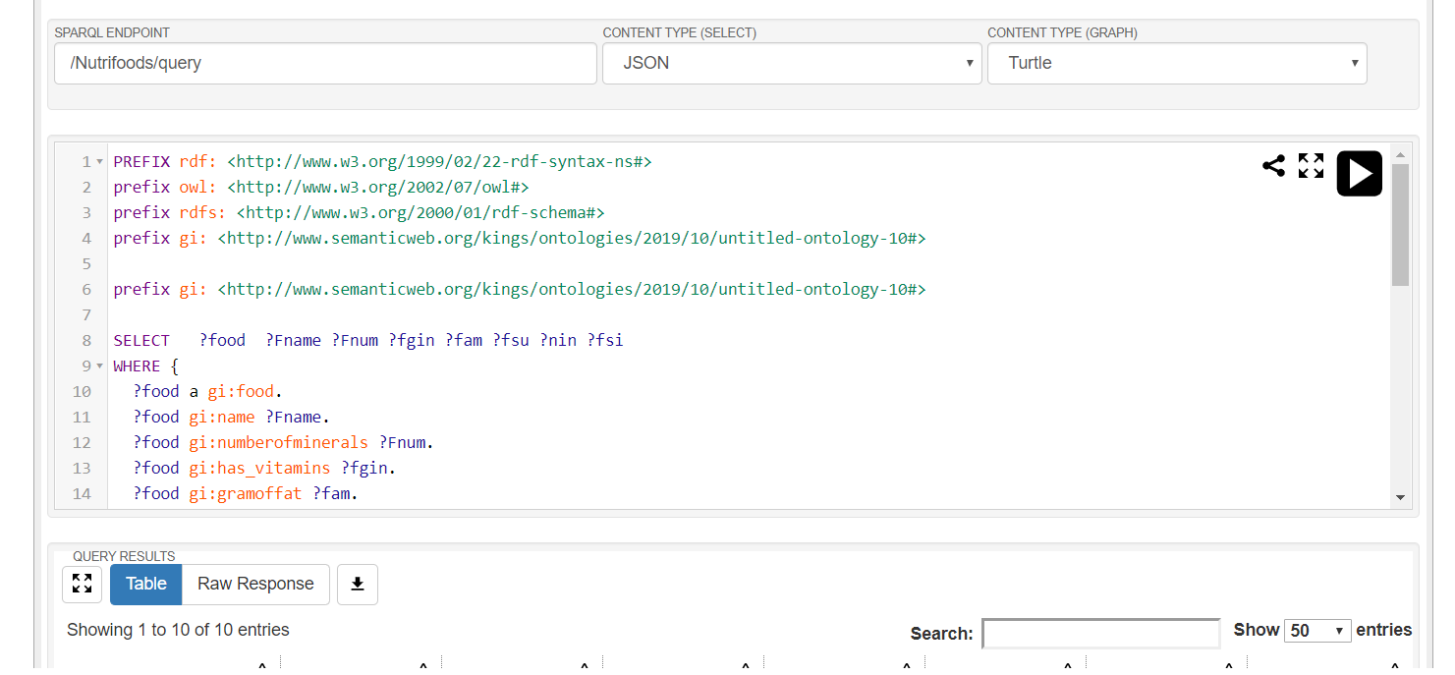

Figure

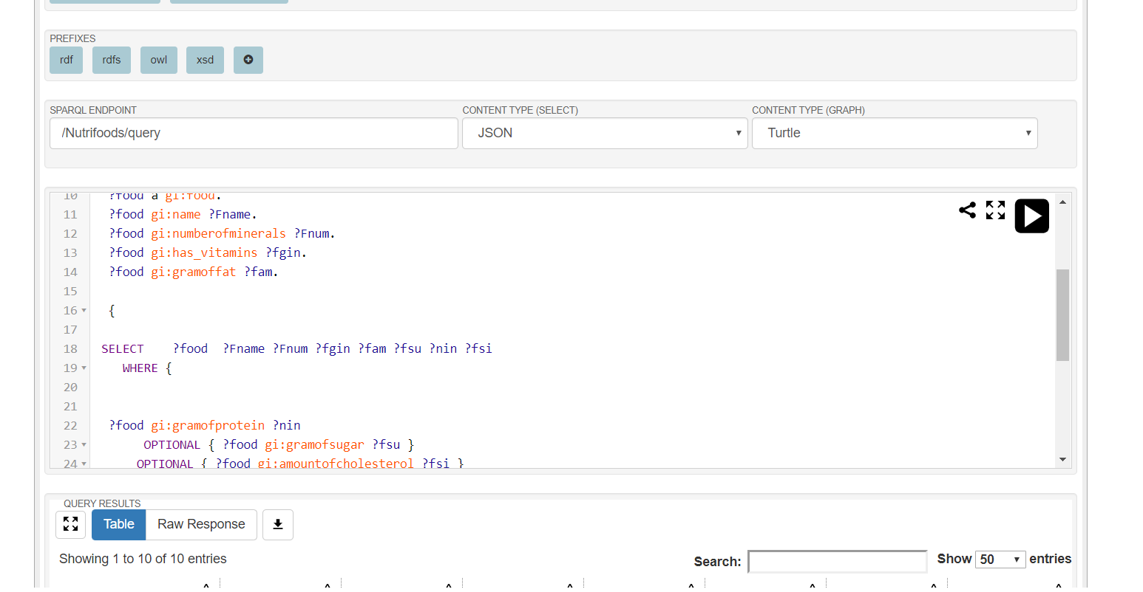

Figure

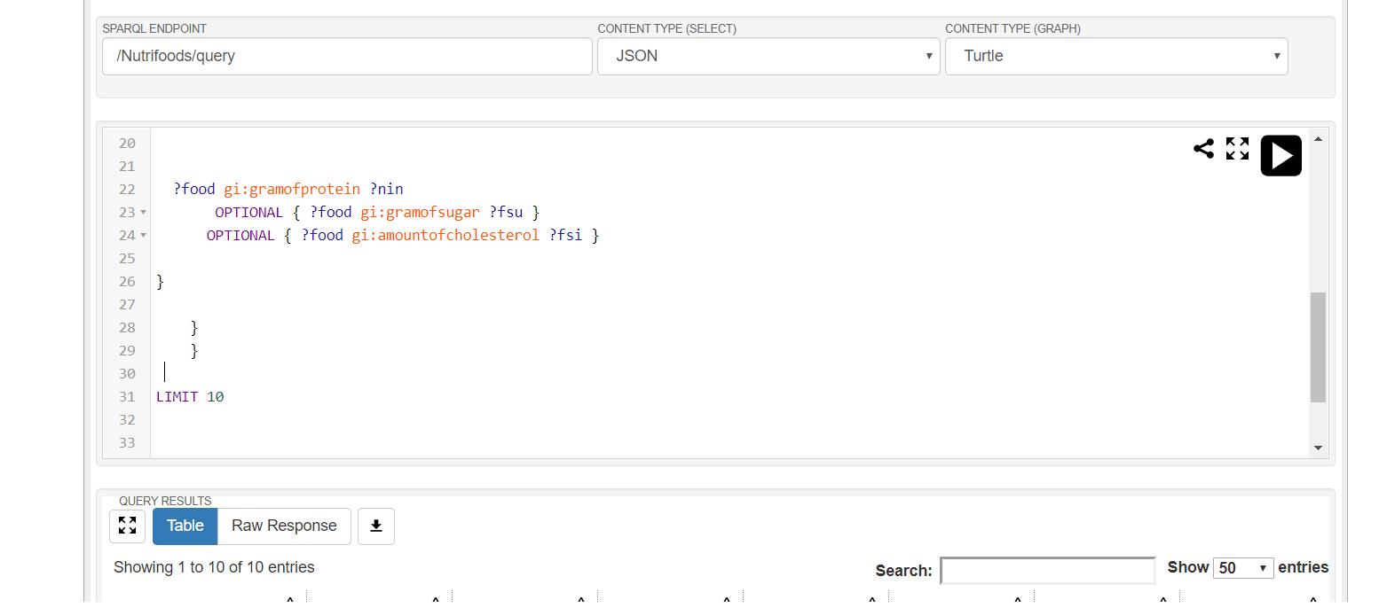

Figure

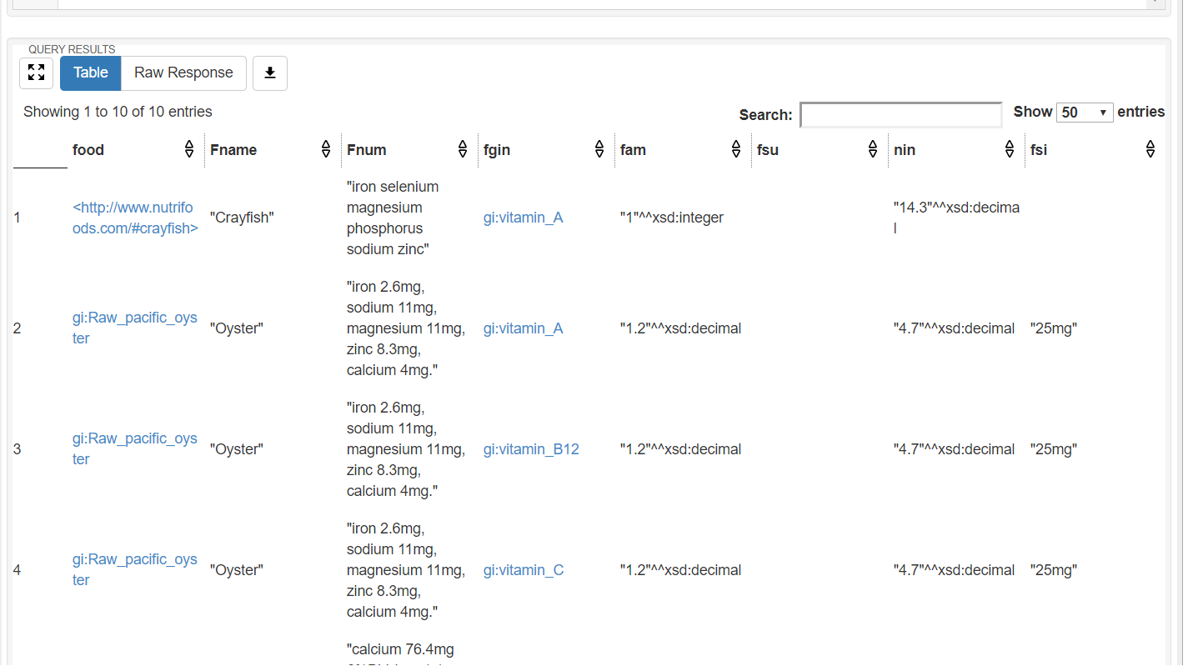

Figure

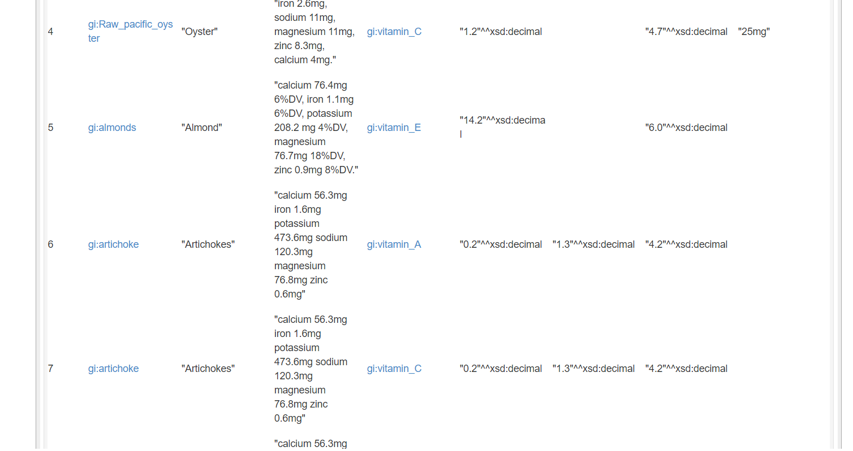

Figure

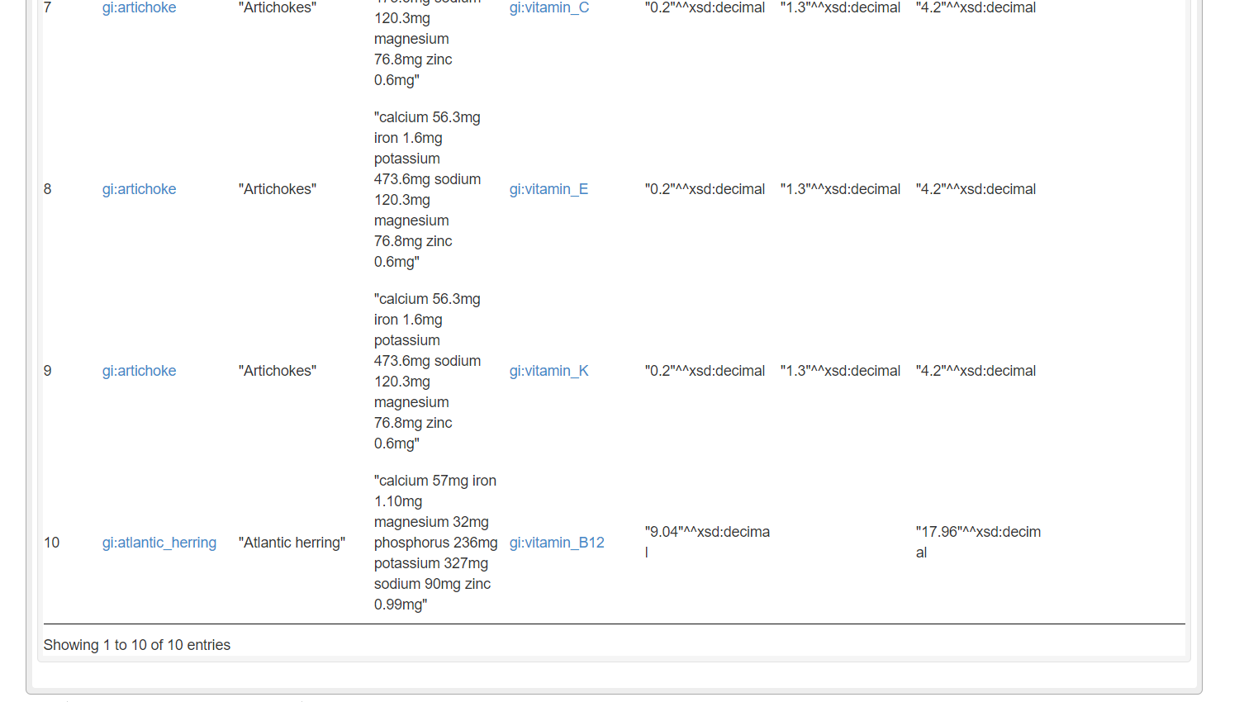

Figure

Figures 35 to 40 shows a query function that gets all the name on the ontology that is a food that minerals recorded to them, has vitamins in them (**has_vitamins**), has an amount of fat (**gramoffat**), has an amount of protein (**gramsofprotein**). The option function gives the condition that even though a food does not have **gramofsugar** and **amountofcholesterol** together with the other attributes that was given to be displayed above still display them.

## Fifth query

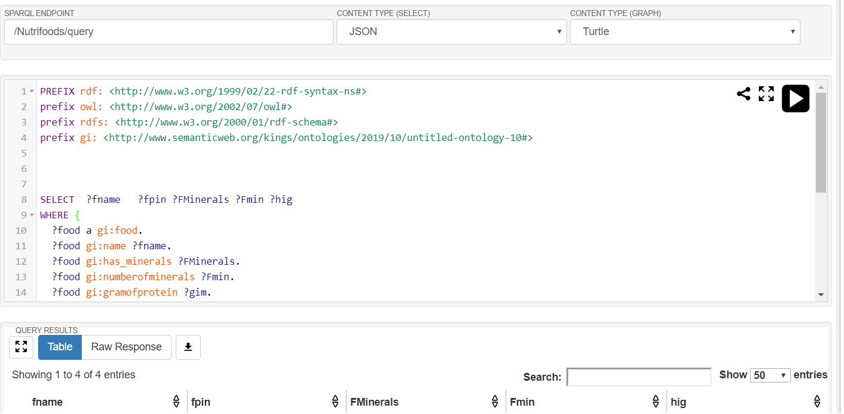

Figure

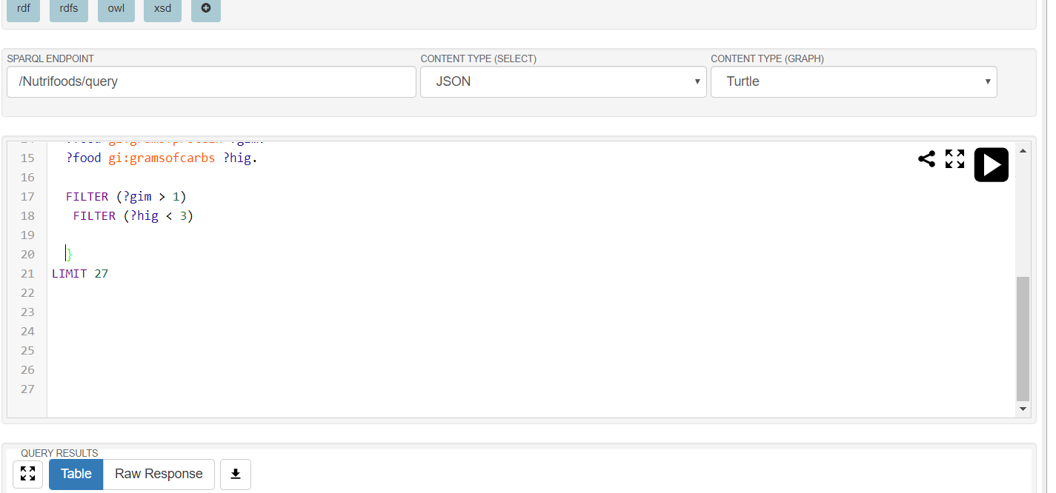

Figure

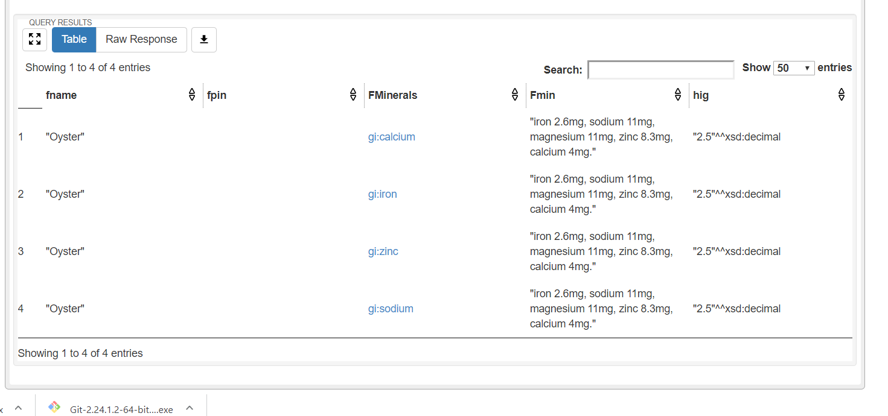

Figure

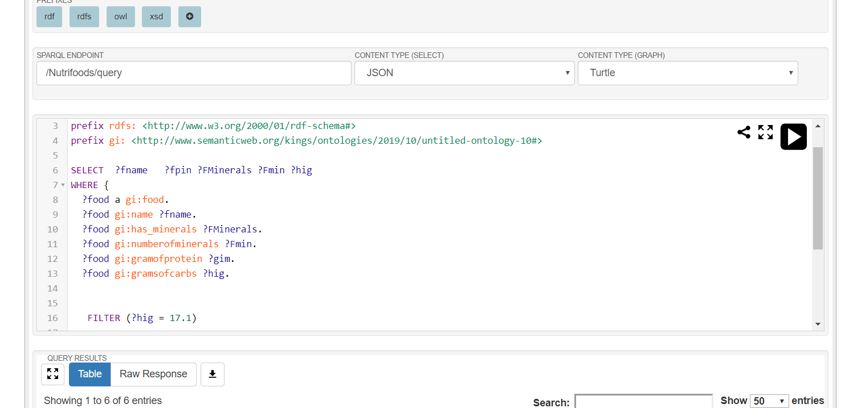

Figure

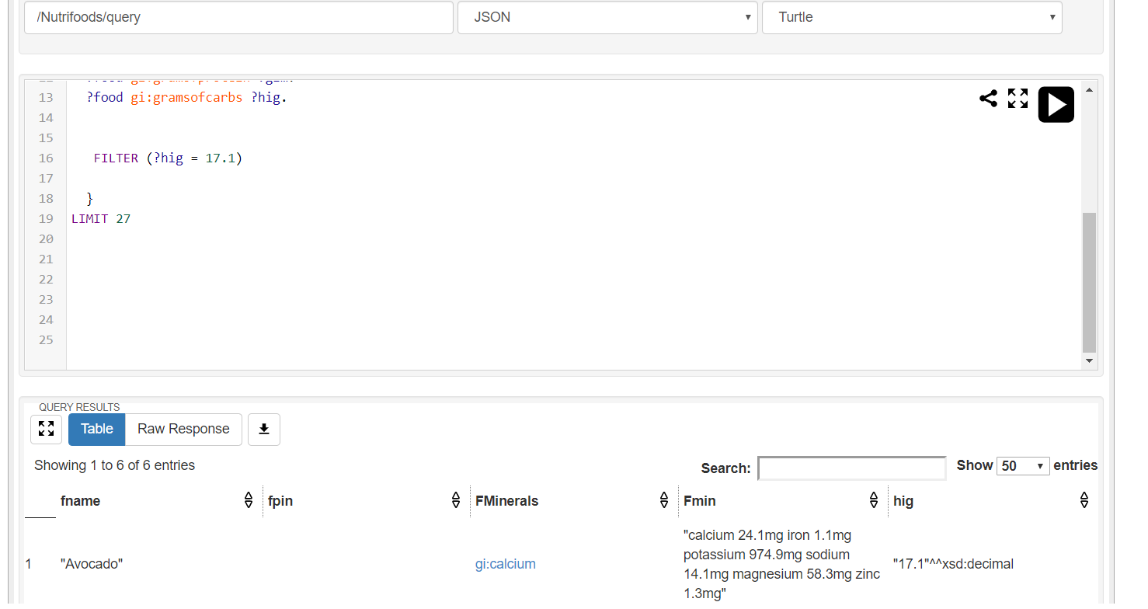

Figure

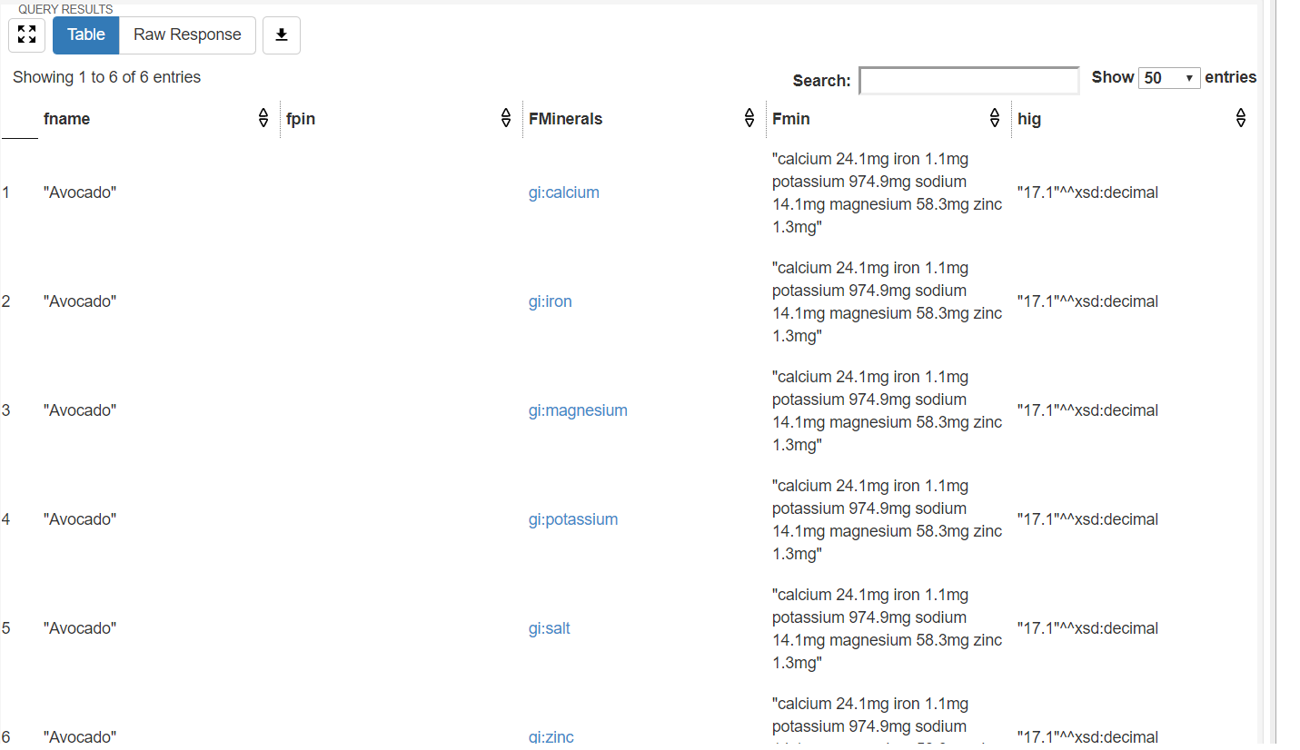

Figure

Figure 41-46 shows different ways of using the FILTER function to get a specific result. Figure 41-43 shows the query for getting a food that has more than 1 gram of protein(**gramsofprotein**) and less than three grams of carbohydrate (**gramsofcarbs).** Figure 44-46 shows the query of finding the exact amount of gram of carbohydrate in a food that is in the database.

# critical reflection

There is some similar application that use sematic data for a food and nutrition website as mentioned in the literature review section of the report. FoodOn ontology and myfooddata.com were the ones reviewed.

FoodOn ontology was helpful in building the classes of the ontology of Nutrifoods. How the object properties link a subject and a object with a predicate. Also, how the data properties were used to insert information into its individual. The major difference as discussed in the literature review section is in the purpose of the ontology. The myfooddata website was another inspiration from were many data and features were gotten from. The website displays nutrient values of a food and it is arranged in such a way it is easy for user to understand, this two attributed were the major feature taken from myfooddata.com website. The major difference is it cannot specifically search for food with specific nutrients as it does not use semantic data technology.

Nutrifoods ontology and web application was created for the purpose of giving users a more accurate, specific and faster way of obtaining information about the nutrients of food. By using semantic data technology Nutrifoods could specifically search for nutrients that are in foods as shown in the Evaluation and Use section of the report by using SPARQL queries. Data properties were used to insert data into the individuals giving them values that were used to give information to the users on the applications front-end.

In summary, The Nutrifoods ontology is an improvement on how information is shown about food from the two existing food systems examined and others. It gives specific information about the nutrients of food and shows the breakdown of each nutrients into the last subclass and shows only the information you needed to see and not all the information at once in protege. In the future the web application can display single first and not displaying everything at once at first and could make the web application more user friendly with more dynamic pages and more links to other websites for more information. The web application can also be improved by being more specific in the searches down to the values of different nutrients and being able to search by numbers and not only words. technique called web data extraction which is a technique used to extract huge amount of data from websites, whereby the extracted data is saved to the local files of the computer being used or to a spreadsheet (a database in table format) ([Webharvy, 2019](https://www.webharvy.com/articles/what-is-web-scraping.html)). Also, the use of autocomplete plugin in the coding of the website can improve the search experience for users. Using APIs will also improve user experience giving it access to more information. Finally increasing the database of Nutrifoods will improve it.

# conclusion

This report explores the ontology called Nutrifoods. It was divided into different sections and sub sections to explain the ontology in detail making it easier to read and understand. It had introduction which sub divided into aims and concept and literature review. This section gave a brief overview of how the structure of the report will look like, the aim of the report and comparing existing ontologies and website were Nutrifoods got inspiration from it building Ontology and website. It also looked at how it improved on the existing concepts by apply semantic data technology.

In the Design section of the report terms used in the semantic data technology were explained along with the design of the ontology. It also gave a brief explanation on protégé (the tool used for the ontology). The definition of sematic web was also given with how it works. The class hierarchy, data properties, object properties, individuals and the relations between the classes were explained and shown in figures.

The implementation section of the report showed the actual web application and the explained few lines codes of how it works. It also discussed the fuseki and PHP (the programming languages used).

The section of Evaluation and Use, five SPARQL queries were used in fuseki. Each query was explained in detail. The section demonstrates how important semantic data technology is when it comes to getting specific information.

Also, critical reflection, the whole application was analysed thoroughly. It revealed how useful the food application of sematic data technology and how it creates new ways of getting information on foods. It also gave some recommendations for future improvements. Finally, references were used when needed to improve points made and enable readers that want to do further research do it.

# References

Anon, 2008. [online] Available at: <https://www.researchgate.net/publication/228887145_What_is_the_Size_of_the_Semantic_Web> [Accessed 11 Dec. 2019].

Cambridge Semantics, 2019. *Introduction to the Semantic Web*. [online] Available at: <https://www.cambridgesemantics.com/blog/semantic-university/intro-semantic-web/> [Accessed 11 Dec. 2019].

Dcc.ac.uk, 2019. *Protégé Ontology Editor | Digital Curation Centre*. [online] Available at: <http://www.dcc.ac.uk/resources/external/protege-ontology-editor> [Accessed 11 Dec. 2019].

Ebi.ac.uk, 2019. *Documentation < Ontology Lookup Service < EMBL-EBI*. [online] Available at: <https://www.ebi.ac.uk/ols/docs/about> [Accessed 11 Dec. 2019].

Jena.apache.org., 2016. *Apache Jena - Apache Jena Fuseki*. [online] Available at: <https://jena.apache.org/documentation/fuseki2/> [Accessed 13 Dec. 2019].

Myfooddata, 2019a. *My Food Data*. [online] Available at: <https://www.myfooddata.com/#readmore> [Accessed 11 Dec. 2019].

Myfooddata, 2019b. *Nutrition Facts For Rice Bran*. [online] Available at: <https://tools.myfooddata.com/nutrition-facts.php?food=20060&serv=wt9> [Accessed 11 Dec. 2019].

Ontotext, 2019a. *What is Semantic Technology?*. [online] Available at: <https://www.ontotext.com/knowledgehub/fundamentals/semantic-web-technology/> [Accessed 11 Dec. 2019].

Ontotext, 2019b. *What is SPARQL - Semantic Search Query Language - Ontotext*. [online] Available at: <https://www.ontotext.com/knowledgehub/fundamentals/what-is-sparql/> [Accessed 11 Dec. 2019].

Service, 2019. *Food Ontology*. [online] Ebi.ac.uk. Available at: <https://www.ebi.ac.uk/ols/ontologies/foodon> [Accessed 11 Dec. 2019].

W3.org., 2019. *Semantic Web - W3C*. [online] Available at: <https://www.w3.org/standards/semanticweb/> [Accessed 11 Dec. 2019].

W3schools, 2019. *PHP Tutorial*. [online] Available at: <https://www.w3schools.com/php/> [Accessed 13 Dec. 2019].

Webharvy, 2019. *Web Scraping Explained*. [online] Available at: <https://www.webharvy.com/articles/what-is-web-scraping.html> [Accessed 11 Dec. 2019].

# Appendices

## Appendix A

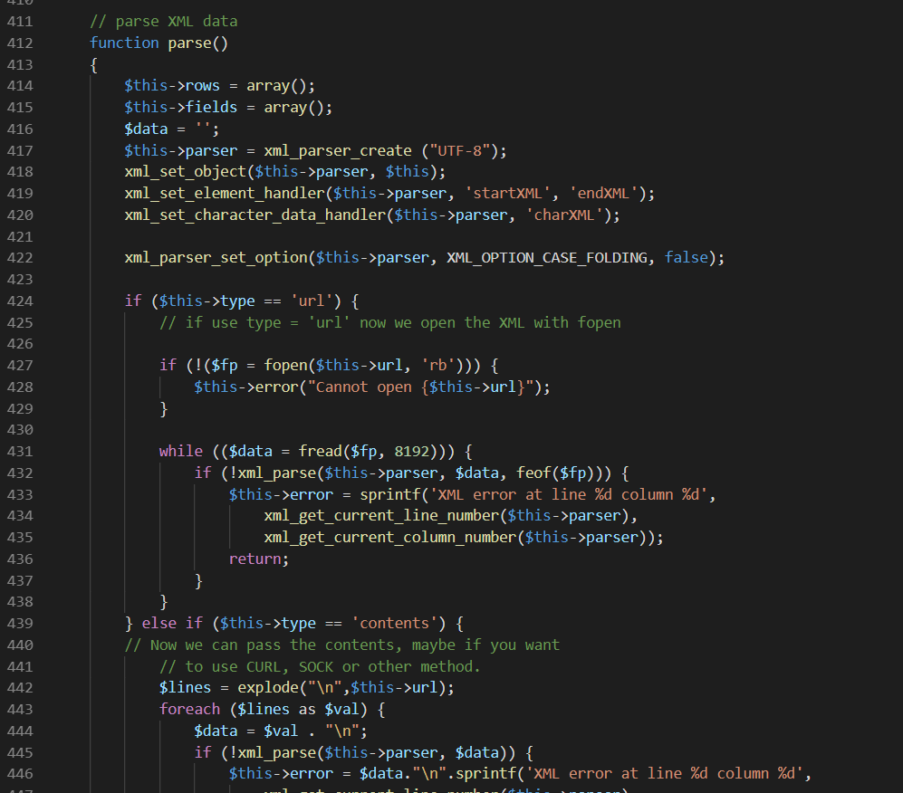

Figure

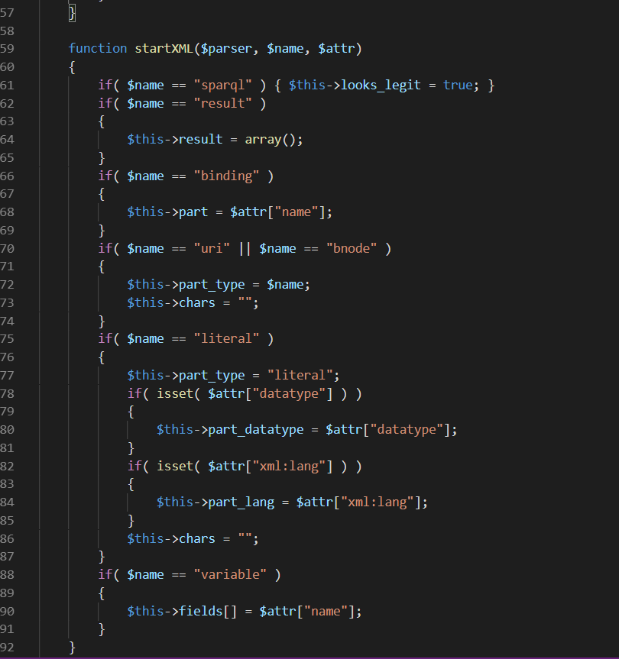

Figure

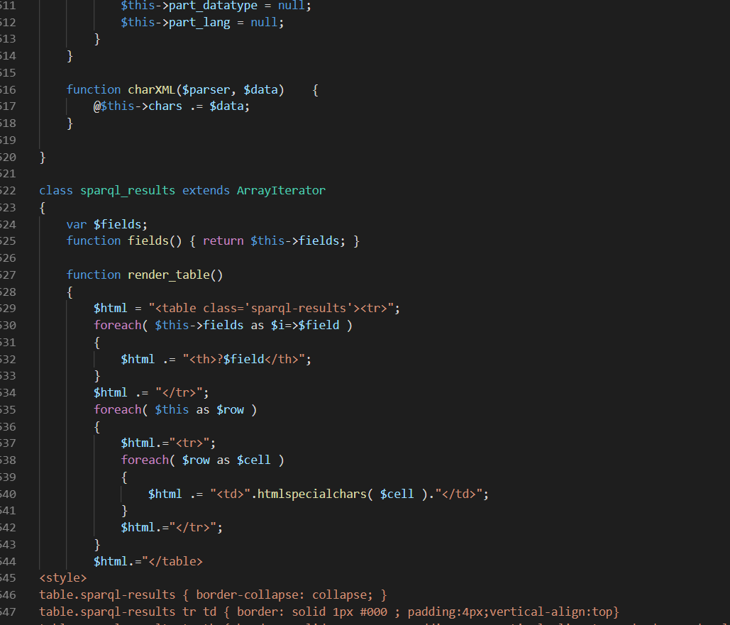

Figure